Exploring Characteristics of Living Organisms

Subject: Life Science
Topic: The students will investigate life cycles, speeds, and sizes of living organisms.
NSTA Teaching Standards: A, B, C, D, E, F

NSTA Content Standards:
Unifying Concepts and Processes:

K-12: Change, constancy and measurement
Science as Inquiry

K-12: Abilities necessary to do scientific inquiry
Earth and Space Science
K-4: Properties of earth materials
5-8: Earth's history
Life Science Standards

K-4: Life cycles or organisms
5-8: Structure and function in living systems

9-12: Behavior of organisms
History and Nature of Science
9-12 Historical perspectives

NCTM Standards

Content Standard: Number and Operations
Process Standards: Connections and Problem Solving

Teaching Procedures:

Essential Questions:

How do plant and animal lifespans compare? What factors contribute to the length of plant and animal lifespans? What is the oldest living organism known to man? How fast are living organisms? How do the speeds of living organisms compare to the speed of humans? How do sizes of living organisms compare to the size of humans? How are human beings different from other living organisms?

Introduction (Activating):
- Begin the lesson with some pictures different living things. As you show pictures of living things, allow the students to classify them according to their own system of classification. You may use the attached pictures or you may supply your own.
- After the students have developed a classification system, introduce the essential questions. "What do you think is the oldest living organism on earth?"
- Ask the students, "What is the average lifespan of the butterfly? (1) 3 hours (2) 3 days (3) a month (4) 3 months."
- Allow the students to form their own hypotheses and discuss the reasoning behind their choices.

Teaching Strategies:
      - Using the pictures you have provided, ask the students to predict the lifespan of each living thing and put the pictures in order from the shortest lifespan to the longest.
      - Distribute the information charts for each living thing. Have the students compare their hypotheses with the information found on the charts.
      - Ask the students how scientists determine the age of trees. With tree ring dating, do the scientists have to chop down the tree to determine how old it is? Discuss how scientists can determine the age of a tree without killing the tree.
      - Discuss the possibility of bacteria as the oldest living organism and define living as continuous.

Closure:
- Have the students write about their thought processes as they discovered the oldest living organism.
- Students should write a summary of their conclusions with possible implications.

Differentiated Instruction:
- As the students are working in groups, circulate to assist when needed.
- Multiple intelligences addressed:
  - Verbal/Linguistic: Students communicate in groups and write about their findings.
  - Logical/Mathematical: Students use numbers to compare the life spans of various living organisms.
  - Spatial: Students consider the number of rings in terms of estimated time.
  - Musical/Rhythmic: Students see patterns in the life cycle/reproduction of living things.
  - Interpersonal: Students discuss possibilities and implications with their group members.
  - Intrapersonal: Students write about their thought processes in an essay.
  - Bodily/Kinesthetic: Groups of students arrange the pictures in order from the shortest to the longest lifespan.
  - Naturalist: Students appreciate the order, beauty and diversity found in nature.

Lesson Assessment:
- Have the students write an essay about their thinking processes in finding the oldest living organism on earth. Use the essay-scoring rubric to assess learning.
- Use the "Discussion Question Handout" student responses to assess learning.

Materials/Resources
- Pictures of living things handouts
- Charts of information on living things
- Discussion Question Handout
- Additional Activity #1: How Long is a Whale?
- Additional Activity #2: Who is the Fastest?
Let's Find the Oldest Living Organism on Earth
Group Discussion Questions

- Examine the pictures of living things found in your handouts. Discuss the lifespans of the items pictured. Determine the order starting from shortest to longest lifespan. Provide a rationale for your choices. Do larger plants or animals have longer lifespans? Do slower animals have longer lifespans? Do plants or animals have longer lifespans? Do insects have longer life spans?

- Why did your group order the pictures as they did? Record the order chosen by the group. Write down your group's rationale for the choices that they made.

- Did you agree with the choices your group made? If not, how did your opinion differ from that of your group?

- Examine the charts that contain information on the life spans of the living things. Put the pictures in order again, this time using the information contained in the charts.

- Compare your group's choices with the actual information. Was your group surprised? If so, what were the differences?

- What is the oldest living organism?

- How old is the oldest living organism?

- How do scientists know this information?

- With tree ring dating, do the scientists have to chop down the tree to determine how old it is? Discuss how scientists can determine the age of a tree without killing the tree.

- What scientific conclusions can you draw from what is known about the oldest living organism?

- What are some of the events in history that have transpired since the bristlecone pine tree, the oldest living recorded organism, first started growing?

- Why do you think this tree been able to survive as long as it has?

- How has the tree changed since it first started growing? Do you think the genetic makeup (DNA) of the tree has changed in the years that it has been growing?

- What can we conclude about earth's history from this activity?

- Go back to the questions posed in item #1. Were you able to answer any of these questions?

- What is your hypothesis on why living organisms have different life expectancies? Would your hypothesis apply to all organisms?

- At times, the study of a particular subject can generate more questions than answers. Has this activity generated any unanswered questions? If so, what are they?

Exploring Characteristics of Living Organisms

What is the Largest Mammal on Earth?
Additional Activities #1 How Long is a Whale?

How Long is a Whale?
Materials: Tape measures or yardsticks and chalk
- Show the students how to draw a scale drawing of a whale using the x and y-axes using both positive and negative numbers for the x value and both positive and negative numbers for the y values. The x-axis will show the length of the whale at 90-110 feet. Explain how to use ratios when creating the scale drawing.
- Distribute the graph paper provided. Have each student make a scale drawing of a whale that is within the length range given for the average whale (90-110 feet).
- Allow each group to choose one of the scaled drawings to reproduce with chalk on the blacktop outside.
- (optional) Allow the students to choose the height measurement of other living thing to draw on the blacktop to compare to the length of a whale. Some suggestions include: (1) draw the tallest redwood tree across the length of a whale or (2) draw an outline of a human next to the whale.
- After the drawings are complete, visit each group and compare the scaled drawing on the paper with the chalk drawing on the blacktop. Point out that the great blue whale is the largest mammal on earth.

Exploring Characteristics of Living Organisms

What is the Fastest Mammal on Earth?
Additional Activities #2: Who is the Fastest?
Who is the Fastest?
- Working in groups, without using the information charts, make a hypothesis to determine the order, from fastest to slowest, of all the living creatures.
- Use the information contained in the living things description charts to rank the fastest living creatures. Put them in order from the fastest to the slowest.
- Create a story problem involving the animals in which one animal is trying to catch up to another animal. Determine how long it will take one animal to catch up to another one if one of the creatures has a head start. (You may alter the head start you will give to the slower animals.)
- Example problem: If a man started running at a speed of 5 miles per hour and he had a one-hour head start on a giraffe, trying to catch him at 35 miles per hour, how long would it take the giraffe to catch the man? (Assume they are running in the same direction.)
- Example solution:
Begin with the formula distance = rate X time.
If H is equal to the number of hours that the giraffe runs, what is the number of hours that the man runs?
The man runs H + 1 hours since the man had a one hour head start.
When will the giraffe catch the man? The giraffe will catch the man when the distances are equal. So, if the distances are equal, then the following equation can be used:
Rate (of the man) X Time (of the man) = Rate (of the giraffe) X Time (of the giraffe)
With the numbers filled in:
5 miles per hour X (H+1) = 35 miles per hour X H
Simplified:

5H + 5 = 35H
Now solve:
5 = 30H
5/30 = H

H= 1/6 or H = 1/6th of an hour or 10 minutes

- Were you surprised by what you found? If so, what surprised you?

Exploring Characteristics of Living Organisms
Essay Scoring Rubric

Name________________________ Date_________________
Part 1: After exploring different types of living things on earth, why do you think the Bristlecone Pine tree is the oldest living organism on earth? Why do you think this particular variety of tree has managed to outlive all other species of organisms? How do your findings compare with historical records?
Part 2: How do plant and animal lifespans compare? What factors contribute to the length of plant and animal lifespans? How fast are living organisms? How do the speeds of living organisms compare to the speed of humans? How do sizes of living organisms compare to the size of humans? How are human beings different from other living organisms?

 | Not Evident (0) | Needs Work (15) | Acceptable (20) | Exemplary (25)
Calculations | No calculations are present. | The calculations are incorrect. | The calculations are correct. | The calculations are correct and detailed.
Mathematical Thinking | There is no evidence of mathematical thinking. | The mathematical thinking is not expressed clearly or is expressed erroneously. | The mathematical thinking is correct. | The mathematical thinking is expressed correctly and in detail.
Scientific Reasoning | No scientific reasoning is present. | The scientific reasoning present is incorrect. | Scientific reasoning is correct. | Scientific reasoning is correct and detailed.
Written Expression | The essay is not related to the topic or the essay is incoherent. | The writing is minimally coherent and/or has many grammar, punctuation, or spelling errors. | The writing is coherent, clear and understandable with few grammar, punctuation or spelling errors. | The writing is very coherent, expressive, persuasive, and clear with no errors.
Total

Camels
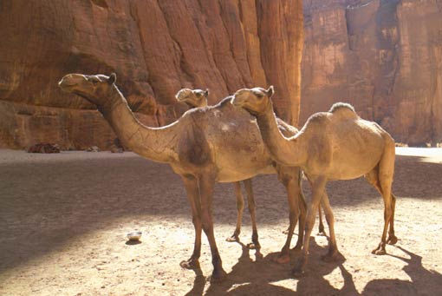

Photo courtesy of National Geographic, 2005. www.nationalgeographic.com

Shark
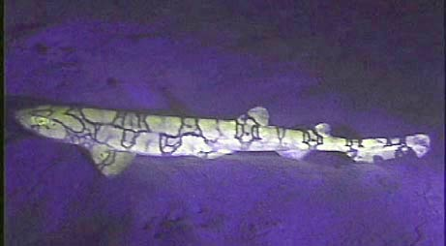

“September 7, 2005—This still photo from a video taken on August 22 shows the first visual evidence of the fluorescent chain catshark. Scientists taking part in the National Oceanic and Atmospheric Administration's Operation Deep Scope 2005 expedition found the three-foot-long (one-meter-long) animal on the sea floor of the Gulf of Mexico.” From the National Geographic Website: http://news.nationalgeographic.com/news/2005/09/0907_050907_glowingshark.html

Giraffe
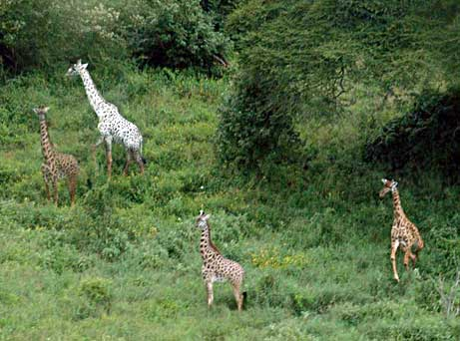

“September 13, 2005—He had only a ghost of a chance, but after more than a decade of searching, a wildlife researcher has captured proof of a white giraffe. In this photo released September 6, the unusual beast and its companions stroll through a wilderness preserve in the African country of Tanzania. Charles Foley of the Wildlife Conservation Society (WCS) first heard reports of the white giraffe in Tarangire National Park in 1993. For 12 years he kept an eye out for the living legend while conducting his daily business of studying the park's savanna elephant populations. ‘By 1994 the sightings stopped coming in, so I assumed it had died, either at the hand of man or beast,’ Foley said in a WCS press release. ‘I never stopped looking though.’
Foley's diligence paid off when he was conducting an aerial survey of the elephants earlier this month and saw a glimmer of white amid the trees. His photo, taken from a plane flying some 62 miles an hour (100 kilometers an hour), shows a pale giraffe with brown coloring on its legs. According to Foley, the animal is not a true albino but is merely a lighter color than the average giraffe. —Victoria Gilman” Information from the National Geographic Website. http://news.nationalgeographic.com/news/2005/09/0913_050913_whitegiraffe.html

Cheetah
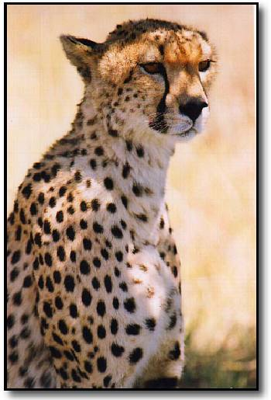

Picture by Michael Wain, www.mcdcwain.freeserve.co.uk

Green Turtle

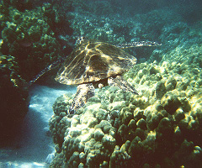

Picture courtesy of Think Quest

Redwood Trees
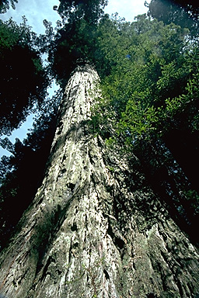
Picture courtesy of Redwood National Park http://www.shannontech.com/ParkVision/Redwood/Redwood.html

Bristlecone Pine
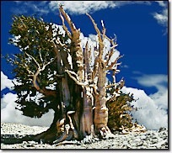
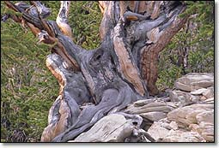
“This bristlecone pine is growing, but it is only supported by the strip of bark seen on the lower right side of the trunk.”
Courtesy of Dr. Edmund Schulman, website:
http://www.sonic.net/bristlecone/Images2.html

Butterfly

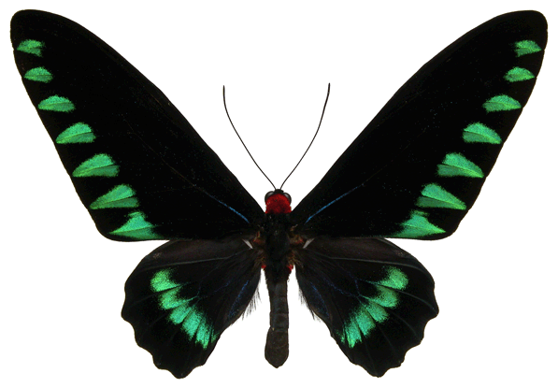

Trogonoptera trojana from Palawan Island, Philippines
Photo courtesy of http://butterflies.aa6g.org/

Morning Glory Bloom

Picture courtesy of the free encyclopedia.
http://en.wikipedia.org/wiki/Morning_glory

Tarantula

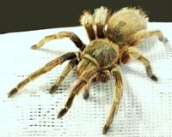

Picture courtesy of Wikipedia, the free encyclopedia located at http://en.wikipedia.org/wiki/Tarantula

Whale

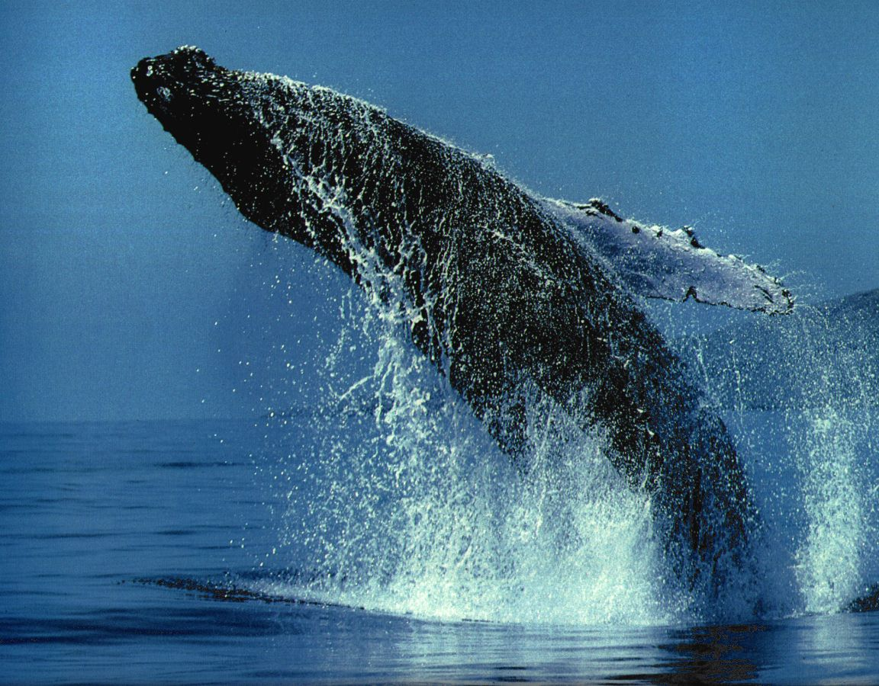

Picture courtesy of http://whales.100freemb.com/gallery/index.html
Humpback from the Whales & Dolphins Calendar 1994

Camel Facts
Average Height | 7 feet (2.1 meters)
Average Weight | 1600 to 1800 pounds (726-816 kilograms)
Speed | 40 mph (65 kph)
Average Lifespan | 50 years
Diet | Plants
Offspring | 1 at a time, possibly 2
Interesting Facts: Camels have been domesticated animals for approximately 3500 years.
Can travel 100 miles without water.
Camels can store up to 80 pounds of fat in their humps.

Sharks
Average Length | 8 inches to 45 feet
Average Weight | up to 15 tons
Fastest Speed | 20 mph (32 kph)
Average Lifespan | Hard to compute, varies. Sharks grow slowly. One cannot examine teeth to determine age. Sharks can live up to 100 to 150 years.
Diet | Fish, marine mammals, other sharks
Offspring | Less than 100 per litter.
Interesting Facts: Sharks do not sleep, they rest.
Sharks are cold blooded and eat less than warm blooded creatures.

Giraffe Facts
Average Height | females 14 feet, males 17 feet, tallest on record, 19 feet
Average Weight | 2420-4250 pounds (1100-1932 kg)
Fastest Speed | 35 mph
Average Lifespan | 15-25 years
Diet | young leaves and the shoots of trees
Offspring | born one at a time
Interesting Facts: Giraffes have elastic blood vessels in their neck to help them not pass out when they bend down to get a drink. Only sleeps for 1-12 minutes.
Each step is approximately 15 feet long. They sleep and give birth standing up

Cheetah Facts
Average Length | 4.3-4.9 feet, tail 2-2.5 feet
Average Weight | 75-150 pounds 45-65 kg
Fastest Speed | 60
Average Lifespan | 12-14 years
Diet | Gazelle, antelope, lizards, eggs, impala, and occasionally fruit
Offspring | 2-5 cubs, up to 8
Interesting Facts: They don’t need to drink water. Cheetahs have been trained by men for hunting since 3000 BC. Cheetahs can reach top speed in 3 seconds. Cheetahs can turn midair while sprinting. Cheetahs once raced against greyhounds. There are cheetahs in Africa, the Middle East, and south-central Asia. Facts from:
http://www.indianchild.com/cheetah.htm

Green Turtle Facts
Average Length | 3 feet
Average Weight | 300 to 500 pounds
Fastest Speed | 35 mph in water
Average Lifespan | 40-70 years old, oldest 177
Diet | Worms, insects and algae while young and sea grass and algae once mature.
Offspring | 80-120 eggs
Interesting Facts: The green turtle can migrate hundreds of miles from its feeding ground to the exact spot that it hatched to lay its eggs. The shell is its skeleton. Many of the green sea turtles nest in Hawaii.
Sources: Animal Planet and Think Quest

Redwood Trees
Average Height | Tallest – 367.8 feet, lost top in 1980’s and 20 feet across
Average Weight
Fastest Speed | 0
Average Lifespan | 500-700, oldest 4,000
Diet
Offspring
Interesting Facts: The Redwoods grow 60-140 inches per year.
Source: Redwood National and State Parks website: http://www.nps.gov/redw/home.html

Bristlecone Pine Trees
Average Height
Average Weight
Fastest Speed | 0
Average Lifespan | Oldest Tree discovered to date at 4,723 years old.
Diet
Offspring
Interesting Facts:

Butterfly
Average Height | 1/2 inch to 12 inches
Average Weight
Fastest Speed | 5-20 miles per hour
Average Lifespan | 20-40 days
Diet | First, it eats its own shell, then juice from rotting fruit and water from puddles.
Offspring
Interesting Facts:
Some species live 3-4 days, others for 6 months.

Morning Glory Bloom

Average | 1 inch or 2.5 cm
Average Weight
Fastest Speed | 0
Average Lifespan | The blooms last only one day.
Diet
Offspring
Interesting Facts:
The leaves and stems are covered with a felt like texture.

Tarantula
Average Length | 1-3 inch body, 3-5 inch leg spans, largest leg span reported is13 inches
Average Weight | 2-3 ounces or 60-90 grams
Fastest Speed
Average Lifespan | Females live 20-30 years; males live 10-12 years.
Diet | Other insects and occasionally other tarantulas
Offspring | 50-200 eggs
Interesting Facts: Sensitive hairs enable the tarantula to detect the size and location of prey from the vibrations caused by movement. The hairs contain mild venom; they can kick off the hairs at a target. They kill their prey by injecting them with venom through their fangs. They taste like shrimp if you are brave enough to eat it.

Information from Wikipedia, the free encyclopedia
http://en.wikipedia.org/wiki/Tarantula#Growth.2C_life.2C_and_mating

Whale
Average Length | 90- 100 feet (blue whale)  Up to 33 meters or 110 feet
Average Weight | 100 tons (male) 150 tons (female), up to 190 tons
Fastest Speed | Up to 30 mph*
Average Lifespan | Whales can live from 15 years (porpoise) to over 80 years (female killer whale)  Larger whales usually have longer lifespans.
Diet | 4 tons of krill per day
Offspring | 1 calf at a time
Interesting Facts: The whale can hold over 1000 tons of food and water in its mouth while feeding. Whales can stay underwater for 15 minutes up to 2 hours depending on the type of whale.

*Information from: http://www.acsonline.org/factpack/bluewhl.htm

