Why Should I Ride a Bike?

Subject: Simple Machines, Measurement and Geometry
Topic: Students will use measurement, geometry, algebra and problem solving to figure out how to find the mechanical advantage of different bicycles.
NSTA Teaching Standards: A, B, C, D, E, F

NSTA Content Standards:
Unifying Concepts and Processes:
K-12: Change, constancy and measurement
Science as Inquiry
K-12: Abilities necessary to do scientific inquiry
Physical Science
9-12: Motions and forces
NCTM Standards

Content Standard: Measurement, Geometry, and Algebra
Process Standards: Connections and Problem Solving

Teaching Procedures:
Essential Questions:
Why should I ride a bike? Which is the best bike for me? How do I know?
Introduction (Activating):
1. Show posters of 4 children with their bicycles. Ask the students which bike they think would be the fastest. Have each group discuss the question and come to consensus on the ranking of the fastest bike and report to the group.
2. Link the concept of the “fastest” bike to the concept of “mechanical advantage.” Ask the students if they think any of the bicycles have mechanical advantage. Guide student discussion as they rank the mechanical advantage of the bicycles shown on the posters.
3. If possible, bring in a bike to demonstrate what happens to the front wheel when the pedals move.

Teaching Strategies:
1. Show handout #1 to the students.
2. Define mechanical advantage as the distance the pedals move compared to the distance that the bicycle moves. The distance the bicycle moves would be in the numerator and the distance the pedal moved would be in the denominator to calculate the mechanical advantage abbreviated MA.
3. Point out the measured distances on handout #1.
3. Allow the students to construct ways determine the distance the pedal moves on Emily’s bicycle (handout #1) compared to the distance the bicycle will move and solve the problem using any method they wish within their groups. This multi-step problem involves calculating circumference. They will also need to use ratios or percents to solve the problem.
4. If needed, supply whole group or individual direction by asking questions that lead the students to figure out how to solve the problem.
5. In a whole group setting, solve the problem for Emily’s bicycle (handout #1) with student interaction.
6. Show Handouts #2 and then #3. Repeat the same process for Marianna’s bike and then for Aldo’s bike. Compare the results with Emily’s bike results.
7. Show Handout #4, Christina’s bike. This is a more challenging question because it has multiple measurements or gears. The algebra used is especially beneficial for this problem because there are 2 variables. Allow the students to explore and then discuss the solution to this challenging problem in a whole group setting. This problem will generate more than one answer because the speeds can change.

Closure:
1. Use the data obtained from the four bicycles to come to a conclusion that will answer the questions posed at the beginning of the lesson. Why should I ride a bike? Which is the best bike for me? How do I know?
2. Allow the students to select the bike that they would ride and/or the gear setting they would choose. Discuss other variables. These variables can include the slope of the riding path, the strength of the rider, and the length of the rider’s legs.
3. Have the students reflect by writing about this problem in their math journals.

Differentiated Instruction:
1. As the students are working in small groups, the teacher should assist individual students with concept development and re-direction when needed. Ask questions that will lead the students to build the knowledge that is needed for solving the problem.
2. Multiple intelligences:
A. Verbal/Linguistic: The students discuss the problem and communicate
verbally.
B. Logical/Mathematical: The students use logic to solve the problem.
C. Spatial: The students use geometry (circumference) to solve the
problem.
D. Musical/Rythmnic: Students recognize the patterns in solving multiple
similar problems using algebra.
E. Interpersonal: The students work in groups to collaborate.
F. Intrapersonal: Students reflect on the problem solving process by
using their journal notebooks.
G. Bodily/Kinesthetic: If available, use an actual bicycle and have the
student demonstrate what happens to the front tire when the pedals
move.
3. Collaborative group work is included throughout the lesson.

Lesson Assessment
1. Assessment Instrument
2. Essay Topic and Scoring Rubric
Homework assignment (optional): bring in measurements of a bicycle to use in class to calculate the mechanical advantage.

Materials/Resources
1. Bicycle Anticipation Guide (5 statements)
2. Handout #1 Definition of a Simple Machine
2. Handout #2 Big Wheel
3. Handout #3 Emily's Bike
4. Handout #4 Marianna's Bike
5. Handout #5 Aldo's Bike
6. Handout #6 Christina's Bike
7. Assessment Instrument
8. Essay Scoring Rubric

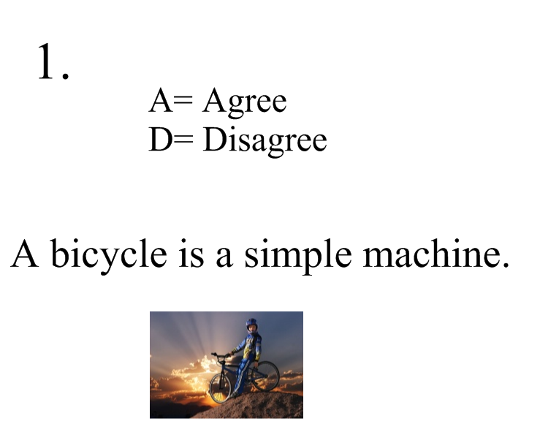
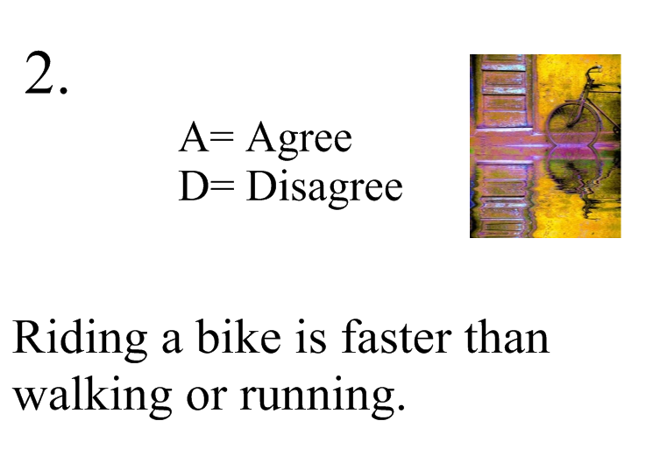

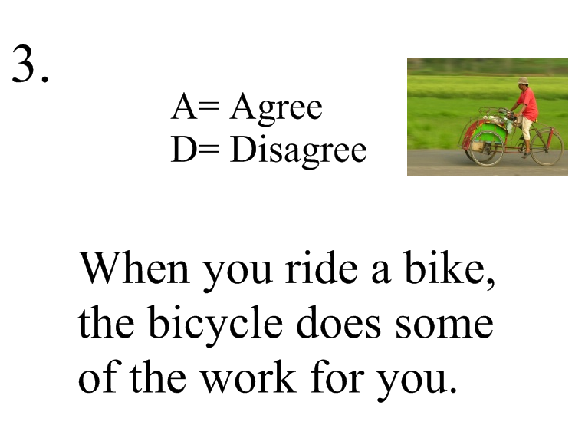

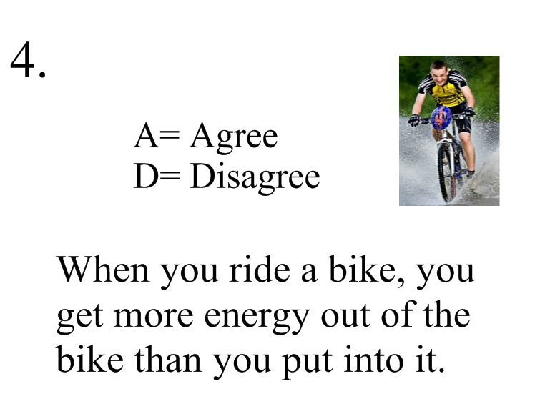
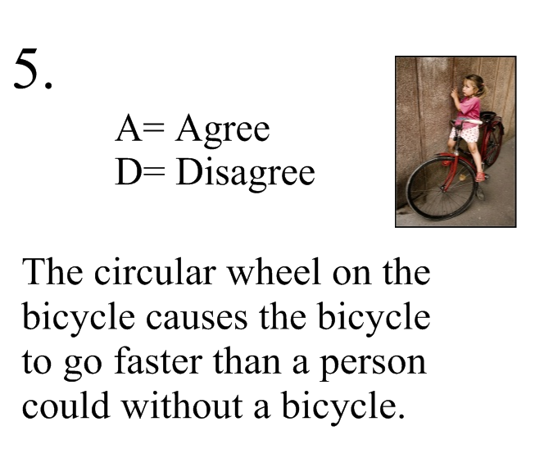

Handout #1
What is a simple machine?

In physics and mechanics, a simple machine is a mechanical device that changes the direction or magnitude of a force. In general, they can be defined as the simplest mechanisms that use mechanical advantage (also called leverage) to multiply force. A simple machine uses a single applied force to do work against a single load force. Ignoring friction losses, the work done on the load is equal to the work done by the applied force. They can be used to increase the amount of the output force, at the cost of a proportional decrease in the distance moved by the load. The ratio of the output to the input force is called the mechanical advantage.
source: Wikipedia

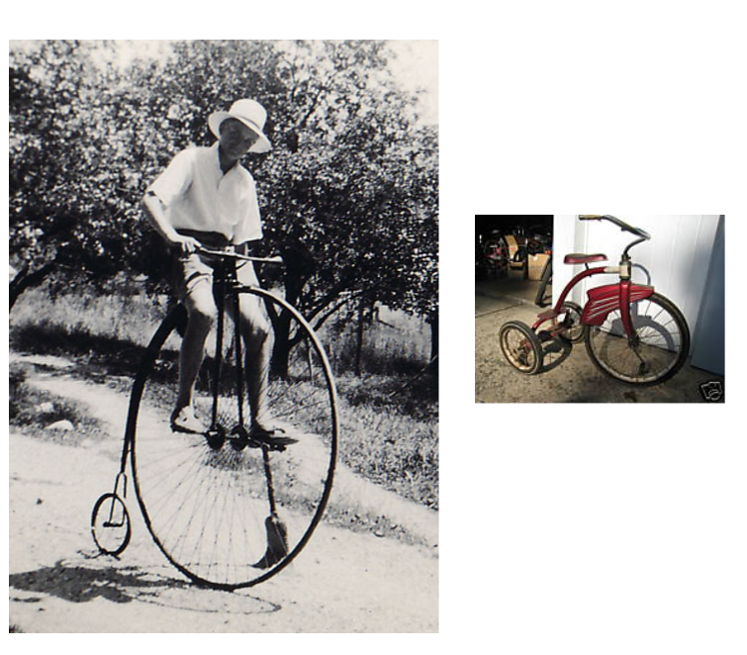

Handout 2

The Big Wheel

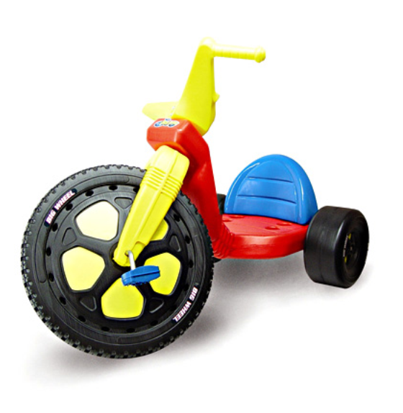
What is the mechanical advantage of this big wheel?

Handout 3

Emily's Bike

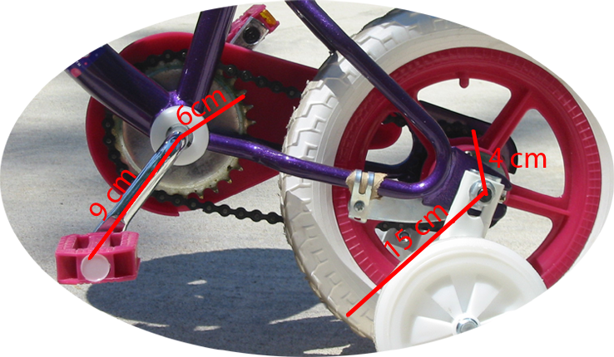
Handout 4

Marianna's Bike

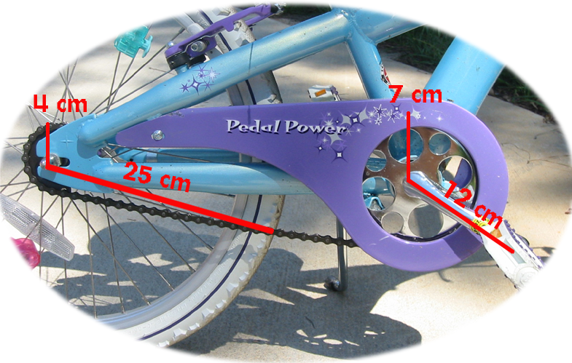

Handout 5

Aldo's Bike

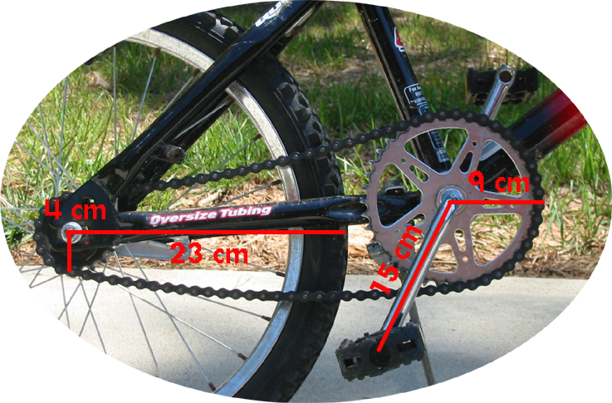

Handout 6

Christina's Bike

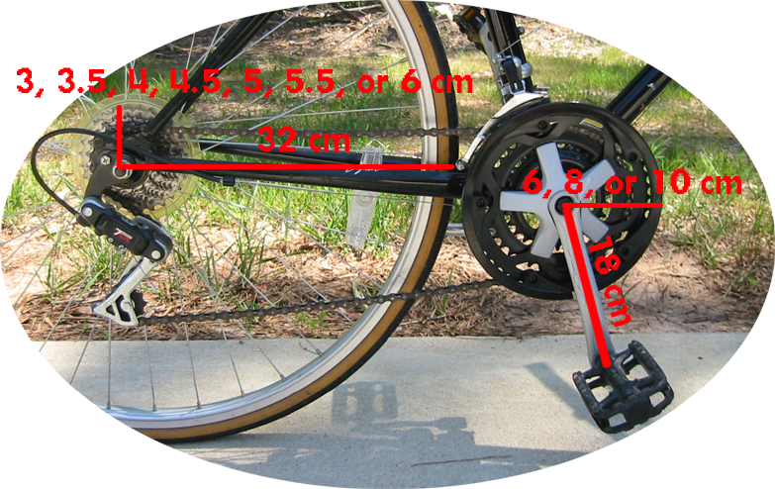

Why Should I Ride a Bike?
Assessment Instrument

Name_______________________________

Date________________________________

1. What is mechanical advantage?

2. Why is mechanical advantage important in designing a bicycle?

3. What is the formula for mechanical advantage?

4. On a separate piece of paper, use the diagram below and algebra to calculate the mechanical advantage of this bicycle. Choose a radius for each gear to use in your calculations. Explain your reasoning and use of algebra.

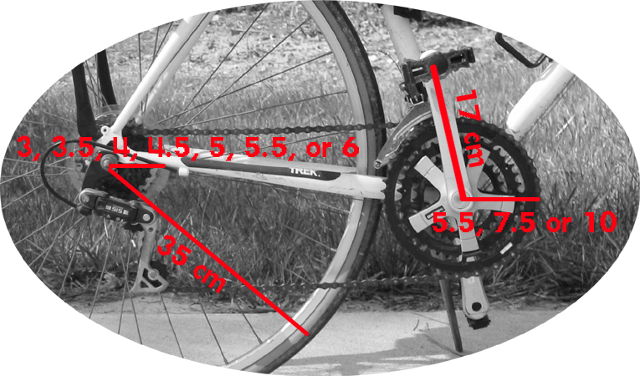

Why Should I Ride a Bike?
Essay Scoring Rubric

Name________________________ Date_________________

Why is it easier and faster to go somewhere on a bike than it would be to walk or run? Explain the concept of mechanical advantage as it relates to riding a bike. Begin with explaining how a big wheel works. Next, provide details on the process of calculating the mechanical advantage of a bicycle with two wheels and gears. When is it better to have a greater mechanical advantage while riding a bicycle? When is it better to have a smaller mechanical advantage while riding on a bicycle?

 | Not Evident (0) | Needs Work (15) | Acceptable (20) | Exemplary (25)
Mathematical Thinking | There is no evidence of mathematical thinking. | The mathematical thinking is not expressed clearly or is expressed erroneously. | The mathematical thinking is correct. | The mathematical thinking is expressed correctly and in detail.
Calculations | No calculations are present. | The calculations are incorrect. | The calculations are correct. | The calculations are accurate and detailed.
Scientific Reasoning | No scientific reasoning is present. | The scientific reasoning present is incorrect. | Scientific reasoning is correct. | Scientific reasoning is accurate and detailed.
Written Expression | The essay is not related to the topic or the essay is incoherent. | The writing is minimally coherent and/or has many grammar, punctuation, or spelling errors. | The writing is coherent, clear and understandable with few grammar, punctuation or spelling errors. | The writing is very coherent, expressive, persuasive, and clear with no errors.
Total

