Big Footprint

Subject: Inquiry and Measurement
Topic: Students will consider the height of a human by examining a footprint fossil replica.
NSTA Teaching Standards: A, B, C, D, E, F

NSTA Content Standards:
Unifying Concepts and Processes:
K-12: Change, constancy and measurement
Science as Inquiry
K-12: Abilities necessary to do scientific inquiry
Life Science
K-4: Characteristics of organisms
5-8: Reproduction and heredity
9-12: Molecular basis of heredity
History and Nature of Science
5-8: History of science
9-12: Historical perspectives

NCTM Standards:

Content Standard: Measurement, Number and Operations (Equivalent

Fractions/Ratios)
Process Standards: Communication, Connections, Representation, Reasoning and
Proof and Problem Solving

Teaching Procedures:

Essential Questions:
Where did the big footprint come from?

Introduction (Activating):
- Show the students the imprint of "Big Footprint." Give them some background information on the print. Scientists found this footprint along with other human footprints of the same dimensions in Glen Rose, Texas, next to the prints of an extinct dinosaur.
- Ask the students to estimate how tall they think the creature could have been. Allow the groups to discuss their thinking. Then give the students some time to record their thoughts on paper.

Teaching Strategies:
- If the students do not come up with the idea on their own, introduce the concept of the length of the foot as a predictor of the height of individuals.
- Have the students trace their footprints on paper.
- Ask the students to measure the length of their feet and compare that with their height. The groups may use either centimeters or inches. When introducing the activity, point out that no matter the unit chosen, the units need to be the consistent.
- Each group should determine the reliability of the measurement of the length of each foot in predicting the height of the individual.
- To test out this theory, allow the students to try to guess the height of another student based on a foot length measurement.
- Each group should determine a ratio that they can use to estimate the height of the source of the "Big Footprint".
- When the group is prepared with the ratio they will use based on their own measurements, direct them to measure the fossil replica of the "Big Footprint."
- Allow the groups to predict what they believe to be the height of the creature that made the print.
- Give each group enough chart paper to recreate a life size image of the creature that could have made the print.
- Provide each group with a discussion guide and have them record their findings in their journal notebooks.

Closure:
- Compare the process they went through with the work on actual scientists.
- Discuss the reliability of interpretative displays in science museums.
- Students should write a summary of their conclusions with possible implications.

Differentiated Instruction:
- As the students are working in groups, circulate to assist when needed.
- Multiple intelligences addressed:
  - Verbal/Linguistic: Students communicate in groups and write about their findings.
  - Logical/Mathematical: Students use ratios to approximate "Big Foot's" height.
  - Spatial: Students view the imprint as an area and the length it relates to height.
  - Musical/Rhythmic: Students use patterns and algebra to approximate height.
  - Interpersonal: Students work in groups.
  - Intrapersonal: Students reflect in journals.
  - Bodily/Kinesthetic: Students investigate their feet, heights, and a fossil replica.
  - Naturalist: Students explore nature as they study footprints.

Lesson Assessment:
- Use the attached rubric for assessing the written analysis of the experiment. (optional)
- Use the discussion guide responses. (optional)

Materials/Resources
- Big Footprint Fossil Replica
- Big Footprint Computation Guide
- Big Footprint Discussion Guide
- Big Footprint Essay Scoring Rubric (optional)

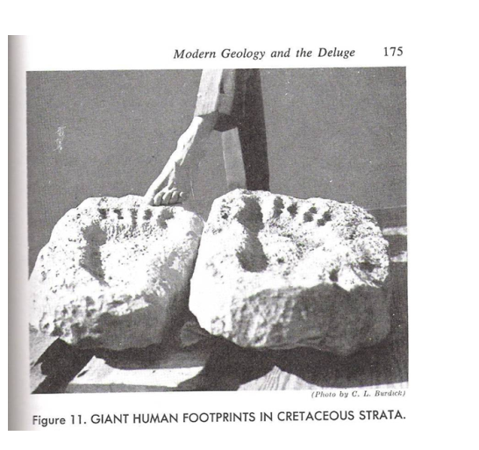

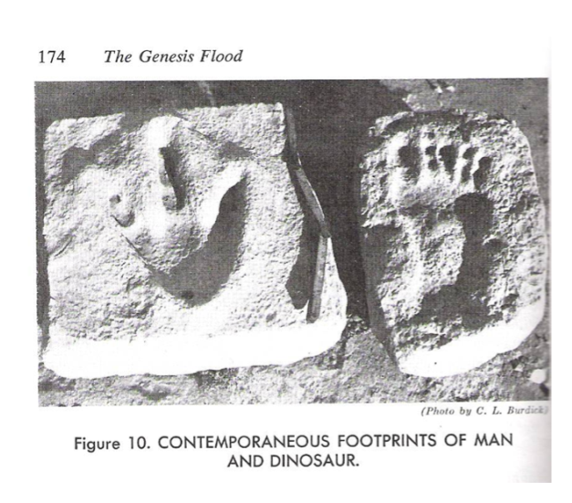

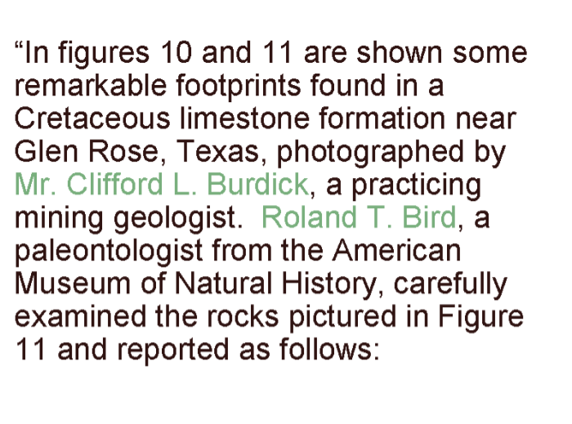
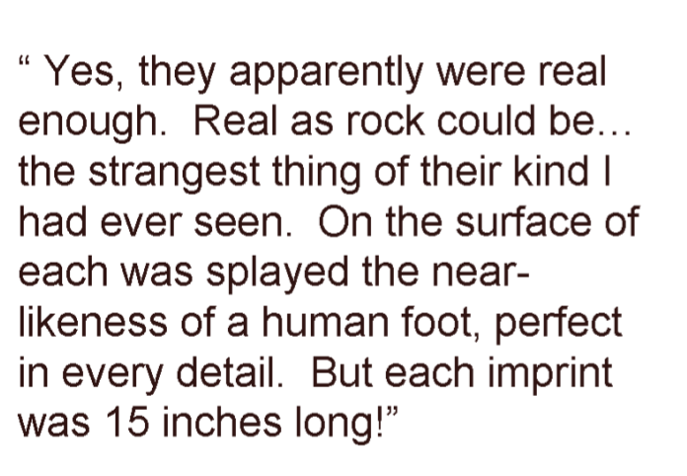

Big Footprint Computation Guide

Begin by setting up the height and foot length as a ratio.

For example: 10 inch foot = 15.5 inch foot
66.5 inch height creature height

Explain how to cross multiply to obtain:

66.5 inches X 15.5 inches = 10 inches X creature height

Explain how to isolate the unknown variable (creature height).
(Divide by 10 inches on both sides.)

1030.75 inches = Creature Height = 103.075 inches
10 inches

If you want the height in feet and inches, just divide the inches by 12.
(1 foot =12 inches)

Your answer should be 8 feet, 7 inches.

Do you know anyone that tall? Would a person that tall fit into this room or
need to bend over to get in the door?

Why do you think people today are not as tall as this person from the past?

Big Footprint Discussion Guide

- How does the length of your foot compare with your height?

- Is there a direct relationship between foot length and height?

- What ratio did you use to determine the height of the creature?

- Is your answer to the creature's height a range or an exact number? How do you know?

- How confident are you in your answer?

- What do you think the creature's weight could have been? What additional information could help you estimate the creature's weight? Explain your reasoning.

- Do you think the creature was a man or woman? What makes you think so?

- Scientists found the creature's footprint next to the print of an extinct dinosaur. What does this tell you about the time when dinosaurs lived?

- Why do you think people today are not as tall the creature, who lived in the past?

Big Footprint Activity
Essay Scoring Rubric

Name________________________ Date_________________

A fossil replica depicts a large footprint, approximately 15 and 1/2 inches long. How might a scientist use math to find out how tall the creature might have been? Do you think the creature was human? Is it possible to calculate the height of the creature that left the footprint with any certainty? How does this ancient creature compare with people today? Why do you think people today are not as tall as the ancient creature, from the past?

 | Not Evident (0) | Needs Work (15) | Acceptable (20) | Exemplary (25)
Mathematical Thinking | There is no evidence of mathematical thinking. | The mathematical thinking is not expressed clearly or is expressed erroneously. | The mathematical thinking is correct. | The mathematical thinking is expressed correctly and in detail.
Calculations | No calculations are present. | The calculations are incorrect. | The calculations are correct. | The calculations are accurate and detailed.
Scientific Reasoning | No scientific reasoning is present. | The scientific reasoning present is incorrect. | Scientific reasoning is correct. | Scientific reasoning is accurate and detailed.
Written Expression | The essay is not related to the topic or the essay is incoherent. | The writing is minimally coherent and/or has many grammar, punctuation, or spelling errors. | The writing is coherent, clear and understandable with few grammar, punctuation or spelling errors. | The writing is coherent, expressive, persuasive, and clear with no errors.
Total

