Human Genetics

Subject: Biology/Genetics
Topic: Students will work problems involving human genetics.
NSTA Teaching Standards: A, B, C, D, E, F

NSTA Content Standards: Biology
- Population dynamics and the impact of population on its environment.
- General concepts of genetics and heredity.
- Organization and functions of cells and multicellular systems.
- Behavior of organisms and their relationships to social systems.
- Regulation of biological systems including homeostatic mechanisms.
- Fundamental processes of modeling and investigating in the biological sciences.
- Applications of biology in environmental quality and in personal and community health.

Advanced NSTA Competencies for Biology Teachers:
- Molecular genetics and heredity and mechanisms of genetic modification.
- Molecular basis for evolutionary theory and classification.
- Issues related to living systems such as genetic modification, uses of biotechnology, cloning, and pollution from farming.
- Historical development and perspectives in biology including contributions of significant figures and underrepresented groups, and the evolution of theories in biology.

NCTM Standards

Content Standards: Measurement, Number and Operations, Probability
Process Standards: Connections and Problem Solving

Teaching Procedures:

Essential Questions:
- How does the human genome function?
- What are the causes and effects of mutations on the human genome?
- In the study of mitochondrial DNA, what are some possible assumptions and implications concerning the geographic ancestry of human populations?
- In the study of the types of x and y chromosomes in human populations, what are some possible assumptions and implications concerning the geographic ancestry of human populations?
- Based on the study of the human genome, what could be considered a reasonable timeline for human populations?

Introduction (Activating):

Show a family picture and ask the students to write an explanation of what they see. (Slide 1)

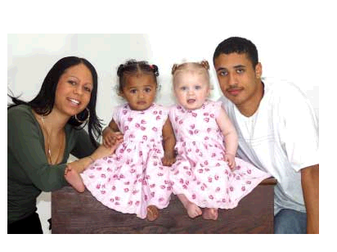

Teaching Strategies:

- Have cards with the following terms and pictures on them: nucleotides, motifs, genes, chromosomes, and genome. Have them arrange the words and pictures into a sequence and explain their sequence.
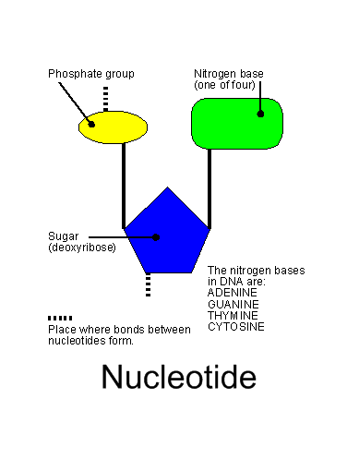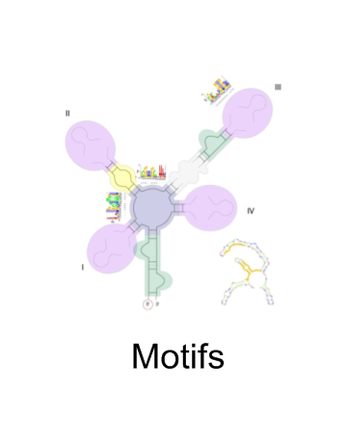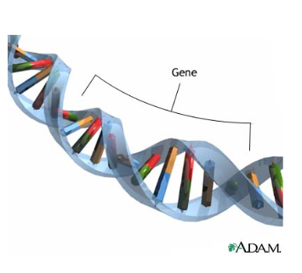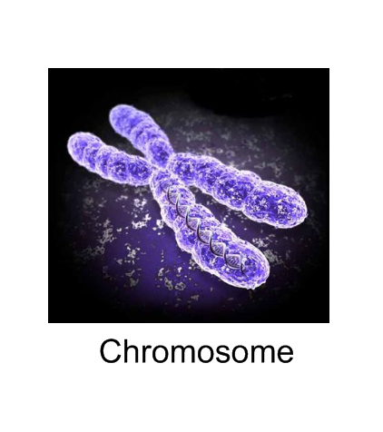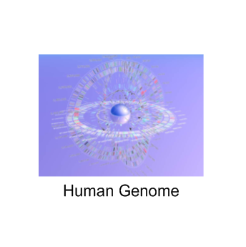
- As a class, put the sequence in order starting with the smallest component. Ask them how many genes they might imagine would make up the human genome. Explain that there are 3.1 billion base pairs in the human genome.

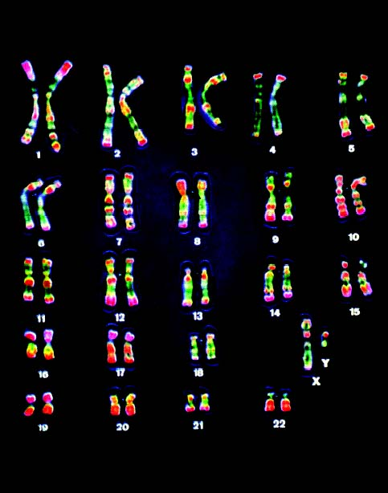
- Introduce some of the proposed assumptions about the history of the human genome. Explain the primary axiom, or the currently most accepted explanation. According to the primary axiom, mutations can account for the existence of the human genome. Ask them if they have any prior knowledge about the history of the primary axiom. In a separate column, compare the secondary axiom. Refer to recorded human history to define the time period of the secondary axiom.

Primary Axiom- Darwin’s Evolution | Secondary Axiom – Recorded History
Mutations and natural selection can account for the existence of the human genome. | The human genome exists.
The human genome began with 10,000 people approximately 1,000,000 years ago. | The human genome began with 2 people approximately 6,000 years ago.

- What is a mutation? Discuss radiation used to produce mutant corn. (Dr. J.C. Sanford)
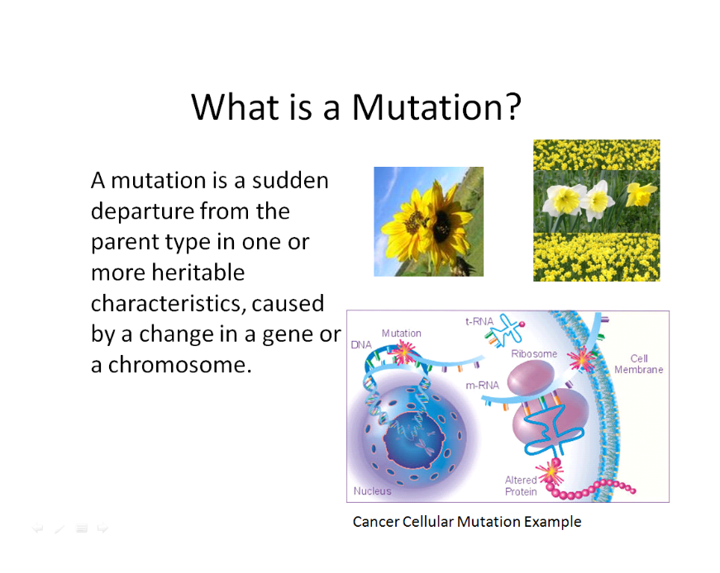
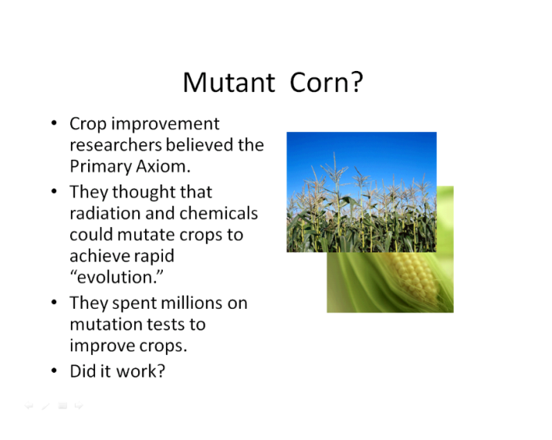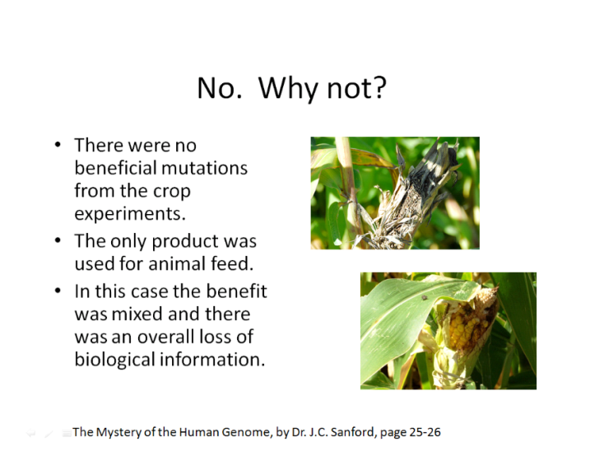
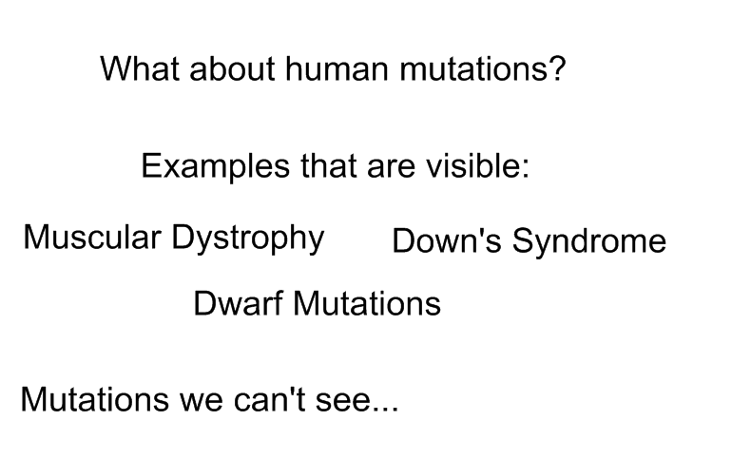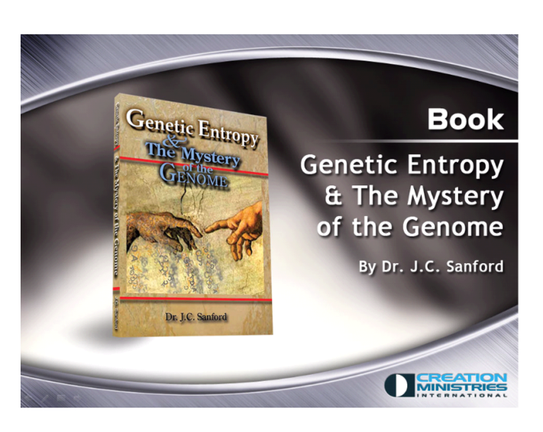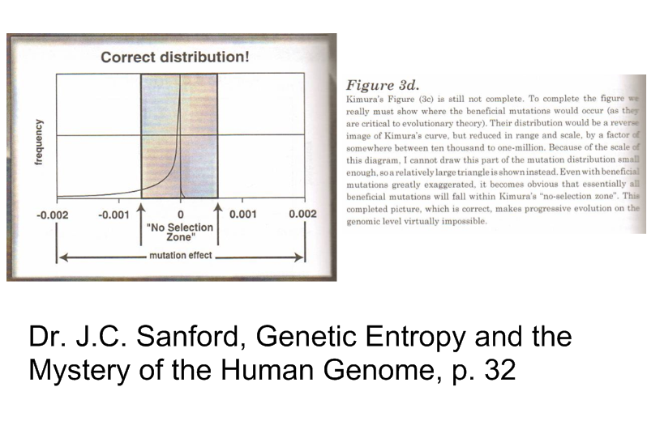

What is the difference between a mutation and a variation?

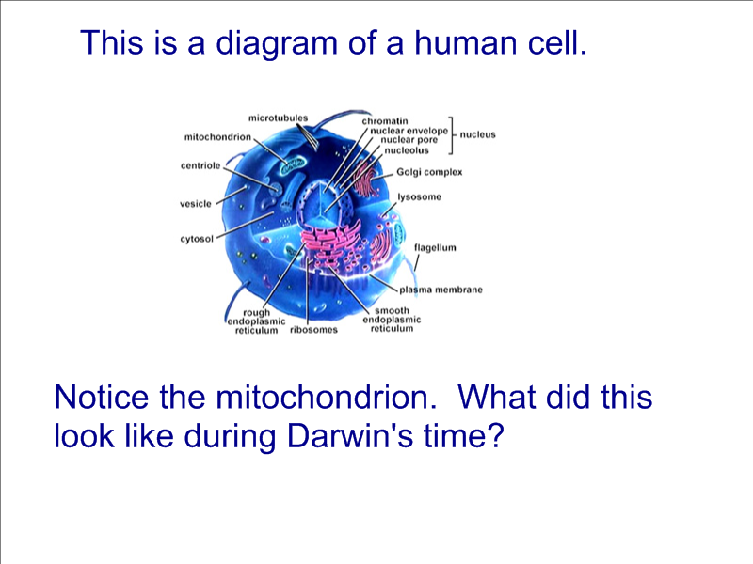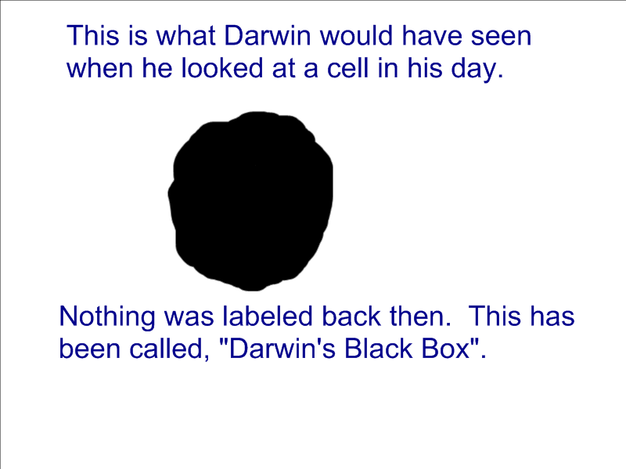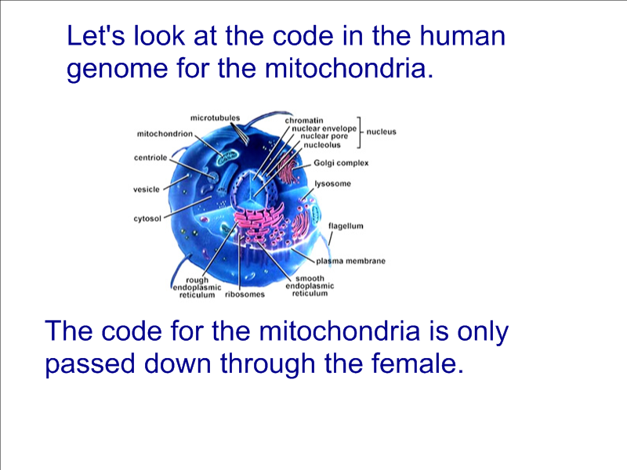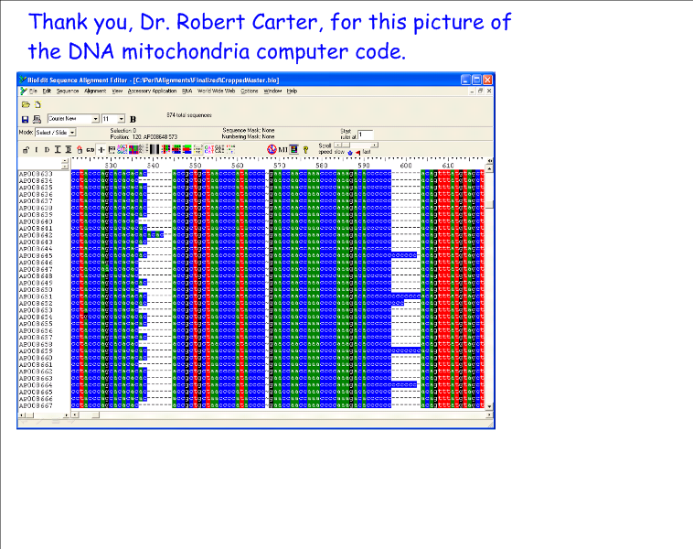
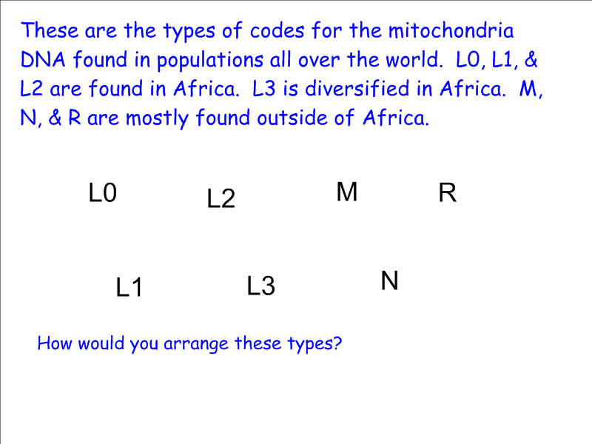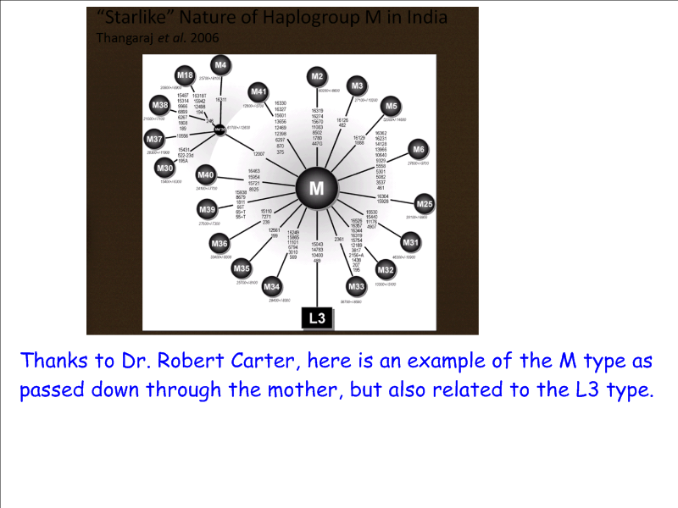
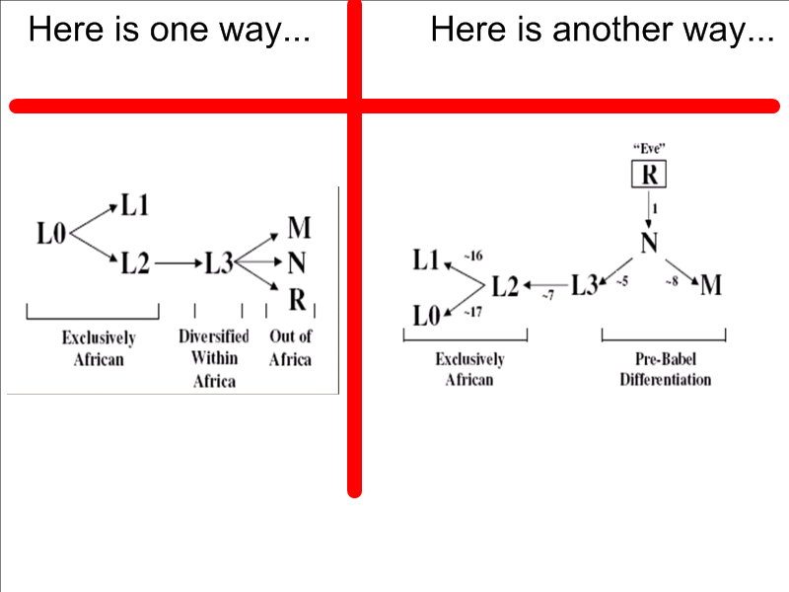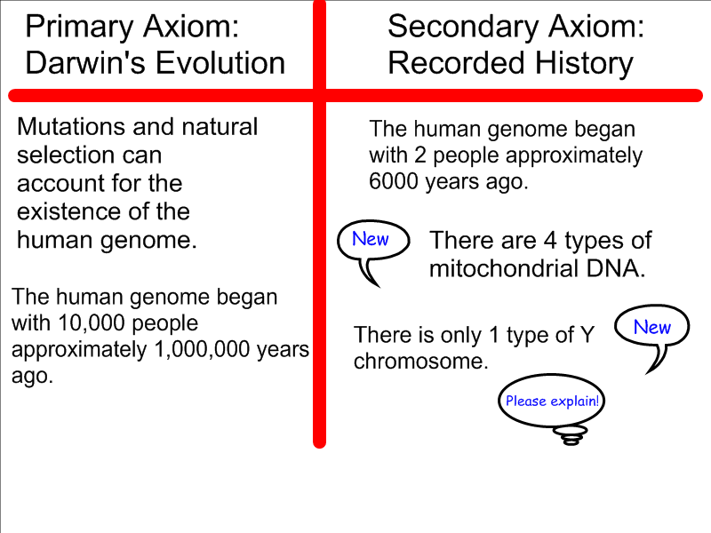
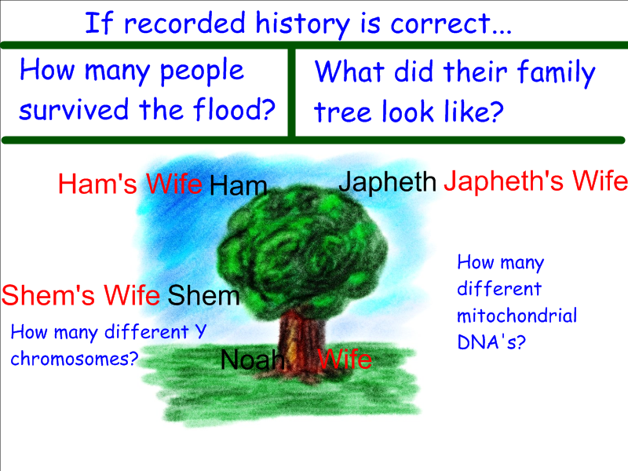
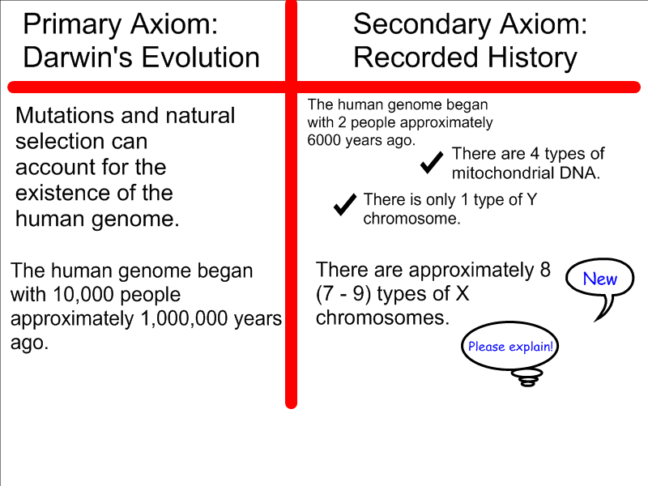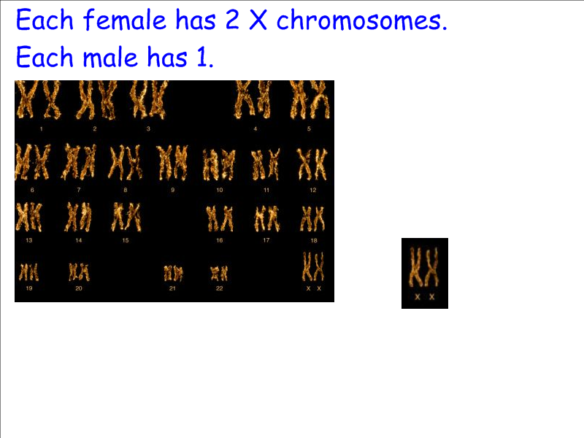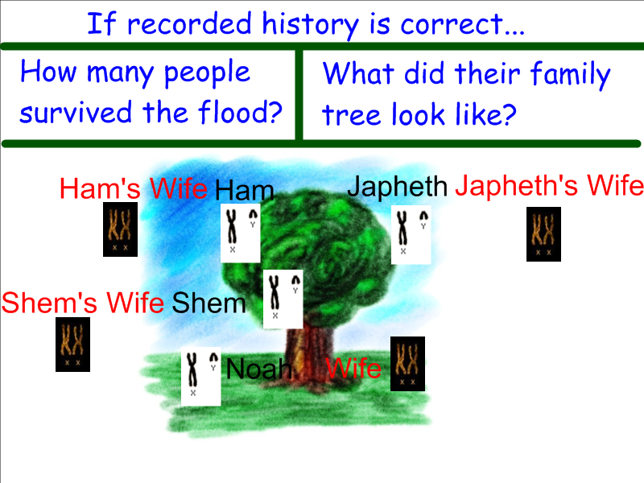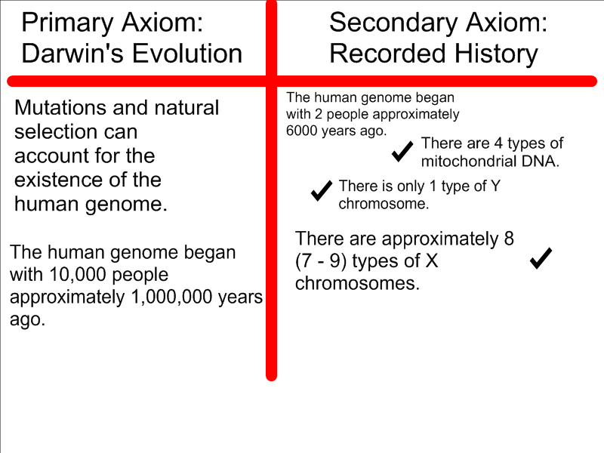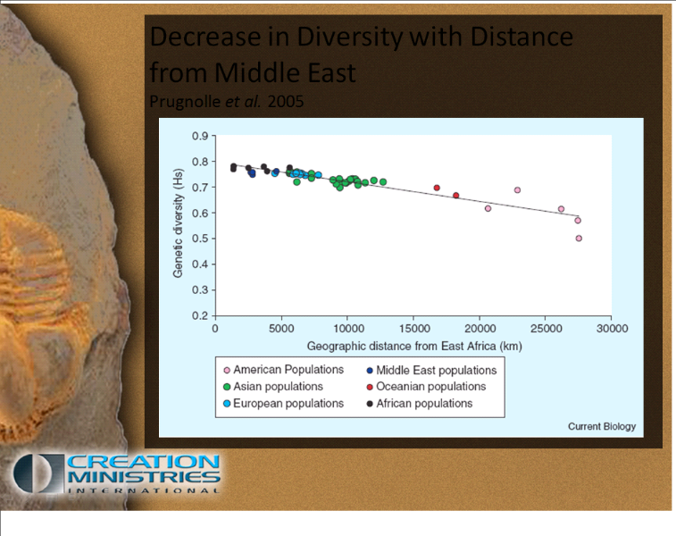

- To extend the learning, the class can discuss the implications of the chart above.
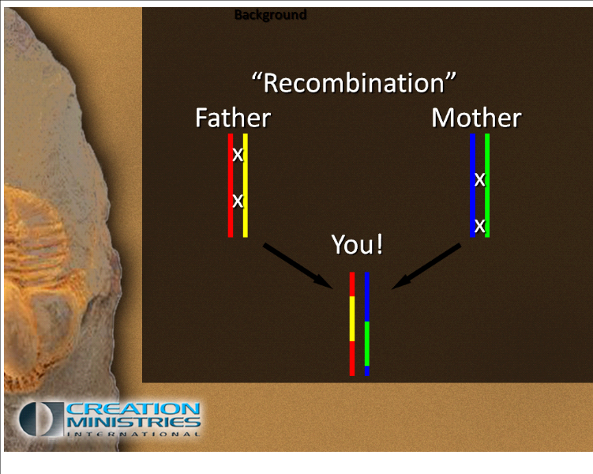
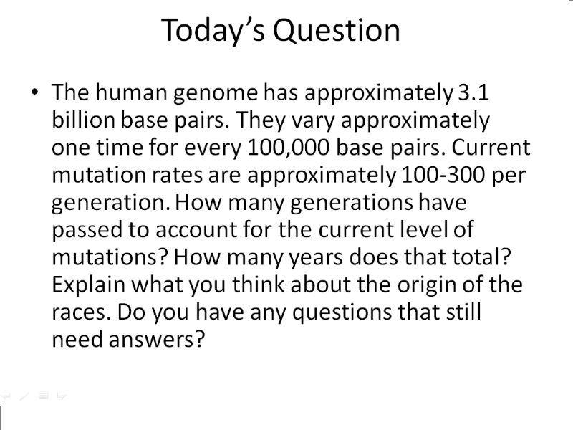
Assuming that mutations have increased at the rate of 100-300 per generation, calculate the number of generations that have passed since there were no mutations.

Extension:

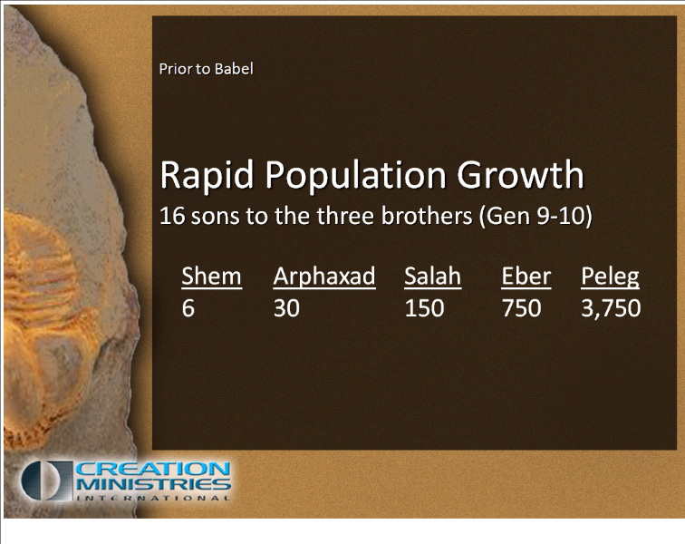

How would we end up with 6 billion people in 4400 years?

Closure:
1. Ask for follow up or related questions they may have.
2. Students should write a summary of their conclusions with possible implications in their journal notebooks.
3. Have the students complete the essay on the mutation rate.

Differentiated Instruction:
1. As the students are working in groups, circulate to assist when needed.
2. Multiple intelligences addressed:
  - Verbal/Linguistic: Students communicate in groups and write about their findings.
  - Logical/Mathematical: Students make choices and calculations to prove or disprove prior assumptions
  - Interpersonal: Students work in groups.
  - Intrapersonal: Students reflect in journals.

Human Genetics
Essay Scoring Rubric

Name________________________ Date_________________

The human genome has approximately 3.1 billion base pairs. They vary approximately one time for every 100,000 base pairs. Current mutation rates are approximately 100-300 per generation. How many generations do you think have passed to account for the current level of mutations? How many years does that total? Explain what you think about the origin of the races. Do you have any questions that still need answers?

 | Not Evident (0) | Needs Work (15) | Acceptable (20) | Exemplary (25)
Mathematical Thinking | There is no evidence of mathematical thinking. | The mathematical thinking is not expressed clearly or is expressed erroneously. | The mathematical thinking is correct. | The mathematical thinking is expressed correctly and in detail.
Calculations | No calculations are present. | The calculations are minimal or incorrect. | The calculations are correct. | The calculations are correct and detailed.
Scientific Reasoning | No scientific reasoning is present. | The scientific reasoning present is minimal or incorrect. | Scientific reasoning is correct. | Scientific reasoning is correct and detailed.
Written Expression | The essay is not related to the topic or the essay is incoherent. | The writing is minimally coherent and/or has many grammar, punctuation, or spelling errors. | The writing is coherent, clear and understandable with few grammar, punctuation or spelling errors. | The writing is very coherent, expressive, persuasive, and clear with no errors.
Total

