How Does Coral Grow?

Subject: Oceanography, Habitats
Topic: Students will discover the age range of the Great Barrier Reef.
NSTA Teaching Standards: A, B, C, D, E, F

NSTA Content Standards:
Unifying Concepts and Processes:

K-12: Change, constancy and measurement
Science as Inquiry

K-12: Abilities necessary to do scientific inquiry
Earth and Space Science
K-4: Changes in earth and sky
5-8: Earth's history
History and Nature of Science
9-12: Historical perspectives

NCTM Standards

Content Standard: Measurement and Number and Operations
Process Standards: Connections and Problem Solving

Teaching Procedures:

Essential Questions:
How does coral grow? How do you think scientists can determine how long the Great Barrier Reef has been growing? What gives a coral its color?

Introduction (Activating):
1. Show the students the pictures of the Great Barrier Reef in handout #1. Discuss the fact that it is visible from space.
2. Ask the students if they think that the reef is alive. Discuss why or why not they would consider the reef either alive or dead.
3. Ask the students if they have any ideas about how scientists might be able to determine how long the Great Barrier Reef has been increasing in size. Ask the students for estimates on a timeframe.
4. Have the students discuss and record their thoughts on paper.

Teaching Strategies:
1. Distribute handout #2. Explain the process by which living coral polyps grow. Explain how algae work to keep the coral reef together. Point out that the Great Barrier Reef is the only living thing visible from space.
2. Refer back to handout #1 as you point out that there are many different coral types and colors. Ask the students why they think this is so.
3. Ask the students why they think there are so many different colors and types of coral. Allow them to discuss possible reasons. Distribute handout #3. Explain the relationship between algae and coral polyps as a symbiotic relationship. Discuss the relationship between the type and quantity of algae living in the coral and color variations. Distribute handout #4 and point out the different types and colors.
5. Ask the students if they think that the growth rate for coral is a constant. Define the term constant as a number that does not change. Some of the students may think that the growth rate of coral varies. If so, ask them what factors they think might contribute to the varying growth rate of coral. The groups should record the ideas that they generate as they discuss this question.
4. Distribute handout #5. Point out the brain coral. Discuss the possible causes in varying rates of coral growth as described in the handout. Ask the students what they think the impact on the growth rate will be due to these causes.
5. Distribute handout # 6, Coral Growing in a Shoe. Ask if the discovery of the coral growing in a shoe can provide any clues about the growth rate of a coral reef. Introduce the information on growth rated from National Geographic and the Australian Institute of Marine Science. Present the information with the opportunity for the students to solve the problem. Provide time for the group members to solve the problem individually. Then, allow time for group work on the problem and discussion. If needed, provide the groups with handout #7, the computation guide.
6. After the groups have had some individual and group time, supply the computation guide to the groups that need it.
7. When a group completes the problem solving, supply them with the computation guide to check their work.
8. After the computations are completed, distribute the discussion guide and allow the students to work in groups as they complete the discussion questions.

Closure:
1. As a whole group, review the questions on the discussion guide.
2. Students should write a summary of their conclusions with possible implications in their journal notebooks.

Differentiated Instruction:
1. As the students are working in groups, circulate to assist when needed.
2. Multiple intelligences addressed:
  - Verbal/Linguistic: Students communicate in groups and write about their findings.
  - Logical/Mathematical: Students use math to approximate the length of time that the Great Barrier Reef has been growing.
  - Spatial: The Great Barrier Reef has a thickness that contributes to the student’s spatial knowledge.
  - Musical/Rhythmic: Students use patterns and algebra to approximate growth rates for coral reefs.
  - Interpersonal: Students work in groups.
  - Intrapersonal: Students reflect in journals.
  - Bodily/Kinesthetic: Living corals are not to be touched, but samples of coral rocks that are no longer living can be brought to class for the students to touch and explore.
  - Naturalist: Students explore nature as they study The Great Barrier Reef.

Lesson Assessment:
- Use the attached rubric for assessing the written analysis of the experiment. (optional)
- Use the answers from the discussion guide for assessment. (optional)

Materials/Resources
1. Handout #1 The Great Barrier Reef
2. Handout #2 Is the Coral Alive?
3. Handout #3 Types of Coral/ Algae and Coral
4. Handout #4 Types of Coral
5. Handout #5 Types of Coral / Coral Growth Rates
6. Handout #6 Coral in a Shoe/ Computation Question
6. Handout #7 Computation Guide
7. Handout #8 Discussion Guide
8. Essay Scoring Rubric

The Great Barrier Reef Handout #1 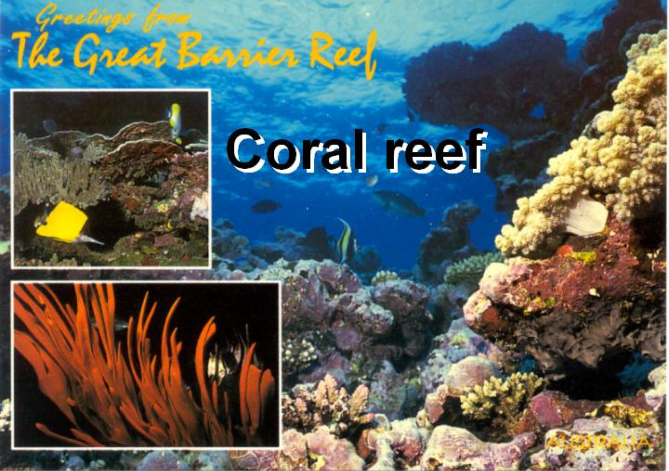
This is a postcard from the Great Barrier Reef. Located just north of Brisbane, Australia, it is the largest known coral reef in the world.
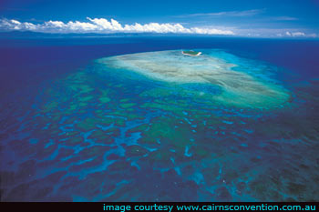
The Great Barrier Reef can be seen from outer space. It is longer than 2300 kilometers. Approximately 2,900 separate coral reefs make up the Great Barrier Reef. (http://www.barrierreefaustralia.com/the-great-barrier-reef/great-barrier-reef-info3.htm)
How does a coral reef grow?
How do you think scientists can determine how long the Great Barrier Reef has been growing?

Handout #2
Is the Coral Alive?

Question: Is the coral alive?

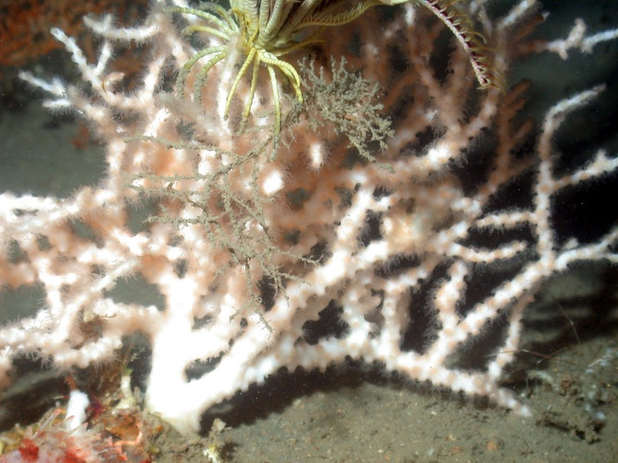

Picture and information courtesy of:
http://www.photolib.noaa.gov/700s/expl0678.jpg

Answer: Yes. The coral polyp produces the limestone structure of a coral reef. Each polyp is shaped like an upside-down jellyfish and sits in a little limestone cup that the polyp secretes. Each polyp has a mouth and tentacles to capture food. As the polyps grow upward, they subdivide. In this way, a single baby coral polyp can grow into a colony with tens of thousands of polyps that can be many meters in diameter. The reef is formed by the growth of many individual coral colonies. When the colony dies, it leaves its skeleton behind. Corals will only live on the surface of a coral reef. Buried beneath them may be thousands of dead coral colonies. Each one left its skeleton behind and these skeletons became the reef structure. Very often, coralline algae grows between the colonies, cementing them together and keeping the reef from falling apart.*

Types of Coral Handout #3

Question: Why are there so many different colors and types of coral?
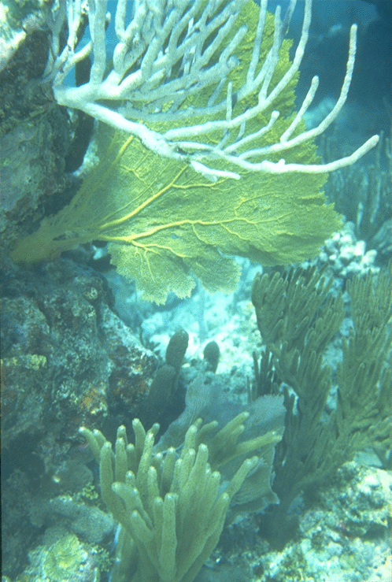
Answer: Coral polyps come in many shapes and sizes. But most corals cannot survive alone. Although each polyp can capture food with its tentacles, the coral is also dependent on a particular alga (called zooxanthellae) that lives inside its tissues. Zooxanthellae produce food for the coral through photosynthesis. The algae take in amonia ("fertilizer") from the coral. In turn, it produces many carbohydrates ("sugars") for the coral. The algae and the coral live in a symbiotic relationship.*

This is a picture of sea whips and a sea fan, two different types of coral, found in the Florida Keys. http://coastal.er.usgs.gov/education/crisis/corals/corals3.html

Types of Coral Handout #4

How do corals get their color?

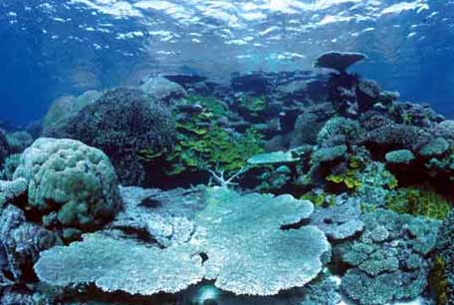
Photograph by David Wachenfeld, Courtesy of National Geographic http://www.nationalgeographic.com/earthpulse/reef/reef2.html#

Most of the color comes from the green and red fluorescent proteins and the purple non-fluorescent proteins that the corals produce.

Zooxanthellae add a dull brown color to the mix.

Brain Coral Handout #5
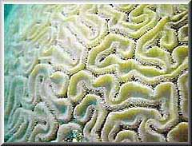

Photo courtesy of the office of naval research:
http://www.onr.navy.mil/focus/ocean/habitats/coral1.htm

Question: Are growth rates for coral constant?
Answer: No.
There are several known factors that affect the growth rate of coral. These are some of the factors:
1. Attacks on the reef by organisms hinder growth.
2. Waves cause reef destruction.
3. A reef that is growing can become thicker by trapping sediments as it grows.
4. Storms can bring in coral from other areas, adding to the thickness of the reef.
5. In studies done on coral reef growth, a temperature increase of 5 degrees Celsius can double the coral growth rate. However, most corals live near the upper limits of their temperature range. A 5 degree increase (in Celsius no less!) in summertime maximum will kill off most all the world's coral reefs. Winter does slow the growth of the coral. There is a delicate balance between temperature increases and the survival of the coral colonies.
6. Increased levels of carbonate in the water can increase coral growth rates. This is because the carbonate will affect the pH. In turn, the pH affects the solubility of calcium. Consequently, the solubility of calcium affects the coral growth rates.
7. Coral can grow faster when it is closer to the surface of the water. However, ultraviolet rays can also have a detrimental effect on the coral reef. At times, as the coral reef grows, the weight of it causes it to sink. Coral can also grow sideways if the water is not deep enough for it to grow upward. Although ultraviolet rays have an effect, this does not prevent corals from growing right up to the surface. Growing coral can even be exposed at low tide.
*Information based on facts from the Office of Naval Research and Dr. Robert Carter.

Coral Growing in a Shoe Handout #6
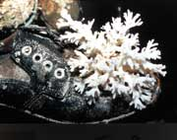
photo courtesy of http://www.answersingenesis.org/creation/v25/i1/coral.asp#f1

Coral growth can be as slow as 1millimeter per year. However, discoveries such as this one have shown that coral growth can be much faster. This shoe has growing coral firmly attached to it. The coral was found growing out of the shoe in waters off the Philippines in 1992. When found, the shoe was less than 4 years old. Does this discovery provide any clues about the growth rate of coral? How fast do you think this piece of coral grew?

Different corals grow at different rates. The coral growing on the shoe is Pocillopora damicornis, which is almost a weed. This species grows very quickly. It is possible to grow a colony that large in an aquarium in about 12 months. Some corals grow a foot or more per year. Other corals grow only a few mm each year. The branching corals tend to grow faster because they only grow in one, linear dimension. Various factors affect REEF growth independently of COLONY growth.

Computation Question for
How Does Coral Grow?
According to National Geographic, corals grow at the rate of approximately ½ inch per year. (http://www.nationalgeographic.com/earthpulse/reef/reef2.html#)
However, more specifically, a study done by the Australian Institute of Marine Science found that a coral colony in the Great Barrier Reef had taken 118 years to grow 6 feet or 1.8 meters. The thickest part of the Great Barrier Reef is about 180 feet or 55 meters. Based on these estimated growth rates, how long do you think the Great Barrier Reef has been growing?

Thank you, Dr. Robert Carter, for your expertise and help in ensuring the accuracy of these materials.

Handout #7
How Does Coral Grow?
Computation Guide
1. After reading the problem, the first step in solving this problem is to identify the available information. We know the following:
It took 118 years for the coral to grow 6 feet or 1.8 meters.
The reef is 180 feet or 55 meters wide at its thickest part.

2. We can solve this by using equivalent fractions.
For example: If we have the number of years (118) in the numerator and corresponding number of feet (6) in the denominator, we can make that fraction equivalent to another fraction with the number of years in the numerator (Y years) and the present thickness of the reef in the denominator (180 feet).
Here is what it would look like:
118 years = Y years
6 feet 180 feet
If we solve for Y, we can cross multiply and get:
118 years X 180 feet = 6 feet X (Y years)
Then, the answer would be
Y years = 118 years X 180 feet
6 feet
Notice that the feet cancel out and the answer is in years.
Y = 3540 years

3. We can also solve this problem using the information from National Geographic. If the reef is 180 feet thick at its thickest part and the coral reef grows at a rate of 1/2 inch per year, how long has the reef been growing?
We can solve this problem by either converting the 180 feet to inches or the inches to feet. If we converted the inches to feet, we would have to work with very small values. So, let's convert the feet to inches instead.
For example:
180 feet X 12 inches = 2160 inches
1 foot
As you can see, the feet cancel out and only the number of inches remains.
So, if there are 2160 inches of coral reef thickness and the growth rate is approximately 1/2 inch per year, how many years have passed since it started growing?
If we take the number of inches and divide it by the number of inches that grow per year, we will be able to calculate the number of years that the reef has been growing.
For example: 2160 inches
1/2 inch per year
To divide a number by a fraction, one may multiply by the reciprocal of the fraction in the denominator.
2160 inches = 2160 inches X 2 years = 4320 years
1/2 inch per year 1 inch

Notice that the inches cancel out and the answer is in years.
Handout #8
Discussion Guide

- Is it possible to know an exact date that the reef began? Why or why not?

- What factors may have influenced the growth rates of the Great Barrier Reef?

- Do you think the coral polyps can survive without the algae?

- Do you think the algae can survive without the coral polyps?

- Why is it important for humans not to touch a growing coral colony?

- How do corals get their color?

- How do we know if coral is alive?

- What is the only structure created by living things that can be seen from space (hint: it is NOT the Great Wall of China!)? Why is this so?

- About how long has the Great Barrier Reef been growing?

- Are you certain about your answer to the question above? Why or why not?

- What do you know about earth's history from your study of the growth rate of the Great Barrier Reef?

Great Barrier Reef Activity
Essay Scoring Rubric

Name________________________ Date_________________

Using scientific and mathematical thinking, describe the factors that have contributed to the growth of the Great Barrier Reef. Use estimated growth rates and the current thickness of the reef to calculate how long the Great Barrier Reef has been growing. How accurate do you consider your answer to be? Explain the factors that influenced your estimates.

 | Not Evident (0) | Needs Work (15) | Acceptable (20) | Exemplary (25)
Mathematical Thinking | There is no evidence of mathematical thinking. | The mathematical thinking is not expressed clearly or is expressed erroneously. | The mathematical thinking is correct. | The mathematical thinking is expressed correctly and in detail.
Calculations | No calculations are present. | The calculations are minimal or incorrect. | The calculations are correct. | The calculations are correct and detailed.
Scientific Reasoning | No scientific reasoning is present. | The scientific reasoning present is minimal or incorrect. | Scientific reasoning is correct. | Scientific reasoning is correct and detailed.
Written Expression | The essay is not related to the topic or the essay is incoherent. | The writing is minimally coherent and/or has many grammar, punctuation, or spelling errors. | The writing is coherent, clear and understandable with few grammar, punctuation or spelling errors. | The writing is very coherent, expressive, persuasive, and clear with no errors.
Total

