White Sands National Monument

**Subject:** Geology and Measurement

**Topic:** Students will consider the processes by which the White Sands National Monument was formed.

**NSTA Teaching Standards**: A, B, C, D, E, F

**NSTA Content Standards:**

Unifying Concepts and Processes:

K-12: Change, constancy and measurement

Science as Inquiry

K-12: Abilities necessary to do scientific inquiry

Earth and Space Science

K-4: Changes in earth and sky

5-8: Earth's history

Physical Science

9-12: Motions and forces

History and Nature of Science

9-12: Historical perspectives

**NCTM Standards**

Content Standards: Measurement and Geometry

Process Standards: Connections and Problem Solving

**Teaching Procedures:**

**Essential Questions:**

1. How did the White Sands National Monument form?

2. What living organisms can survive in the White Sands National Monument?

3. How long did it take the White Sands to form?

**Introduction (Activating):**

1. Begin by showing the students the gypsum crystals and the sand samples. If you do not have any sand or samples, use handout #1.

2. Ask them what they think they have in common. Have the groups discuss the possible relationship between the crystals and the sand. Let the groups come to a consensus on the relationship.

**Teaching Strategies:**

1. Locate the White Sands National Monument using earth.google.com.

2. Using handout #2, show pictures of the White Sands National Monument and ask the students if they think that anything can live in this harsh and desolate environment.

3. Ask the students how long they think the white sands have been there.

4. Review the group responses on the relationship between the gypsum crystals and the sand. Using handout # 3, explain how the crystals from Lake Lucero break up to form the white sands.

5. Use handout #4 to show the types of living organisms that inhabit the sands.

6. Get the students ready to problem solving by asking them how long they think it has taken the sands to spread. Use handout #5 as clues for them to use in solving the problem.

**Closure:**

1. Have each group discuss their findings with the class.

2. Students should write a summary of their conclusions with possible implications.

**Differentiated Instruction:**

1. As the students are working in groups, circulate to assist when needed.

2. Multiple intelligences addressed:

1. Verbal/Linguistic: Students communicate in groups and write about their findings.
2. Logical/Mathematical: Students use ratios to problem solve.
3. Spatial: Students use scaled maps to measure area.
4. Musical/Rhythmic: Students use patterns and algebra to approximate dune formation.
5. Interpersonal: Students work in groups.
6. Intrapersonal: Students reflect in journals.
7. Bodily/Kinesthetic: Students touch the sand and gypsum to note similarities and differences.
8. Naturalist: Students explore nature as they study the White Sands National Monument.

**Lesson Assessment:**

1. Use the attached rubric for assessing the written analysis of the experiment. (optional)
2. Use the discussion guide as an assessment. (optional)

**Materials/Resources**

1. White Sands Activating Activity Handout #1
2. White Sands Handout #2
3. Lake Lucero Handout #3
4. Can Anything Live Here? Handout #4
5. Reflection of Scientific and Mathematical Thinking
6. Essay Scoring Rubric

Handout #1

White Sands Activating Activity

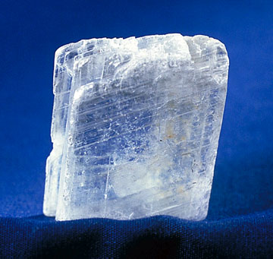

Synonms for GYPSUM: Selenite, satin spar, and alabaster

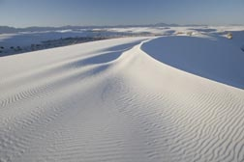

White Sands National Monument Handout #2 The White Sands National Monument page 1

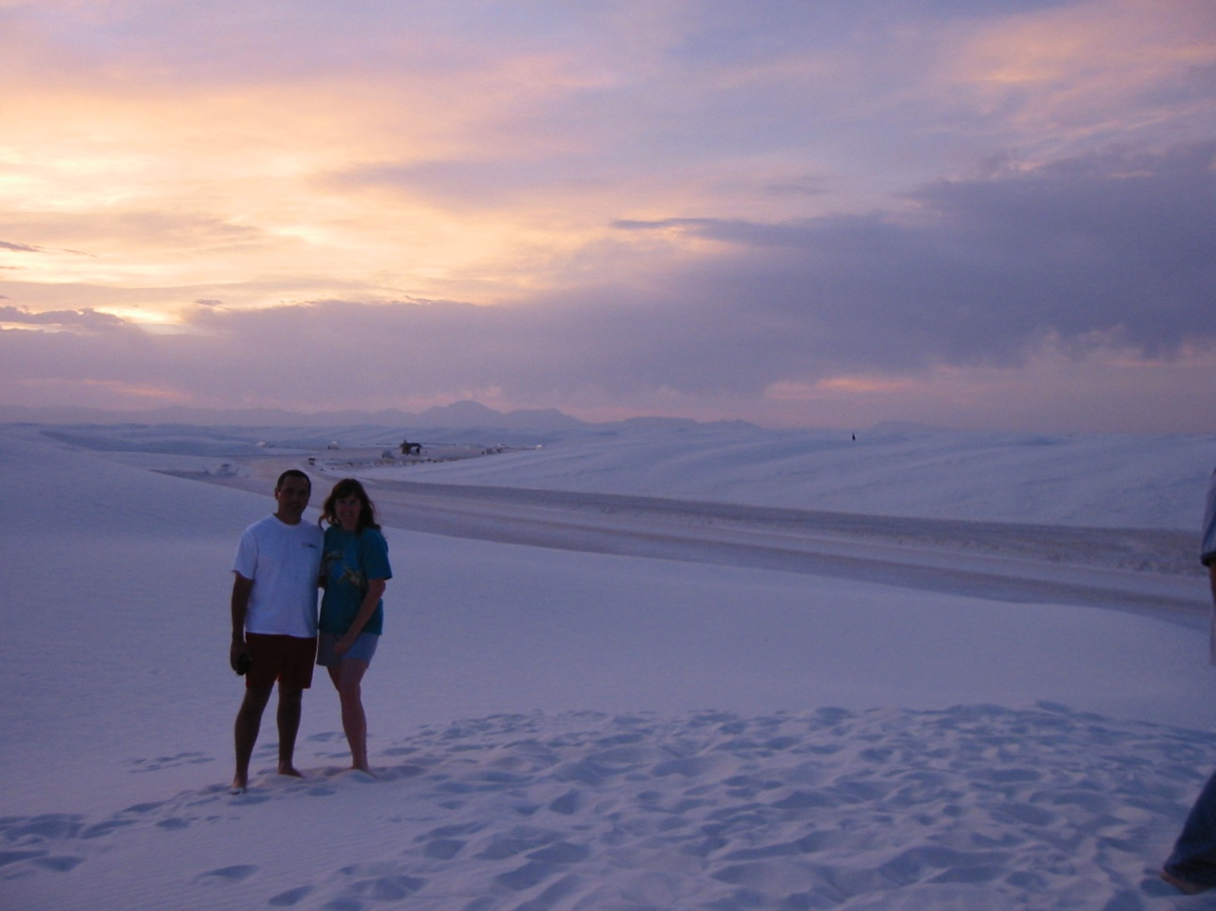

Aldo and Mary Kay Bacallao at White Sands National Monument June 6, 2004

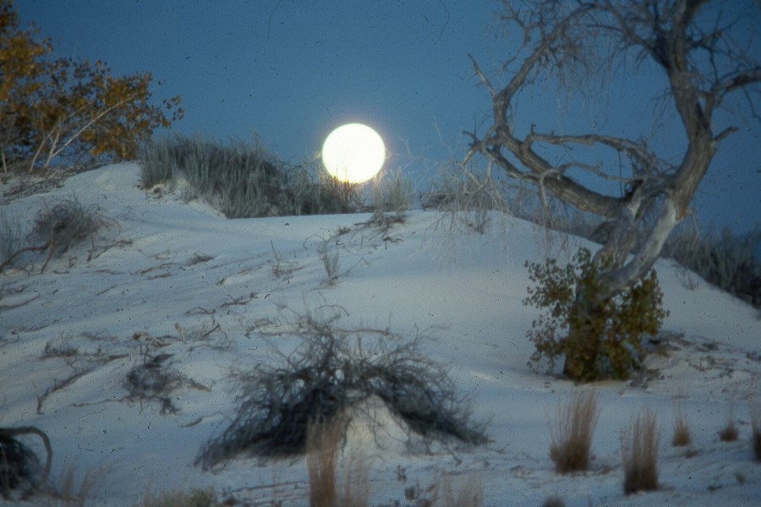

White Sands, Photo Courtesy of National Park Service

Handout #2 page 2

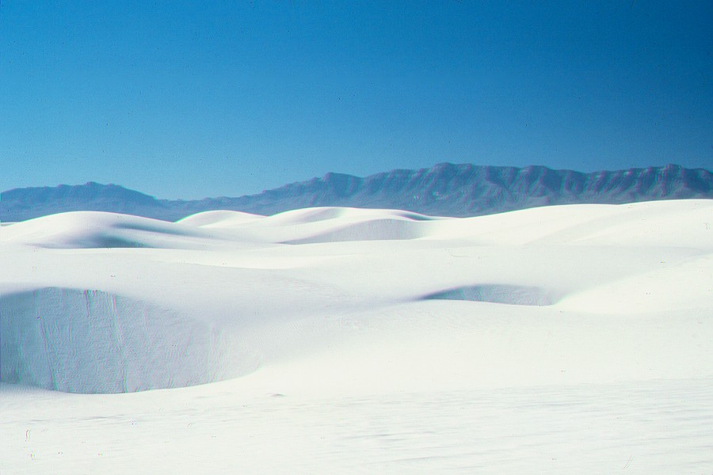

Dunes Courtesy of National Park Service

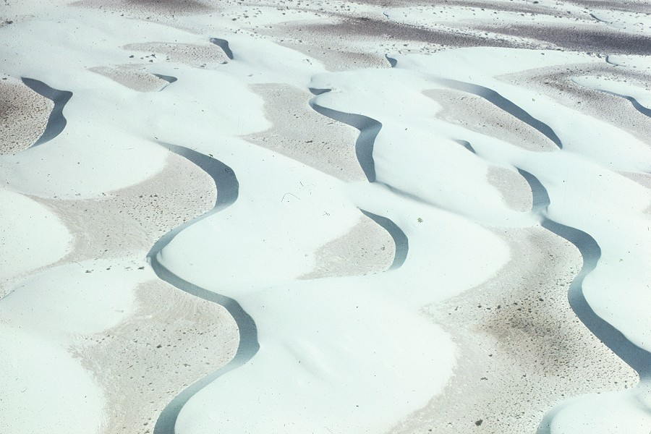

Aerial View Courtesy of National Park Service

Handout #2 page 3

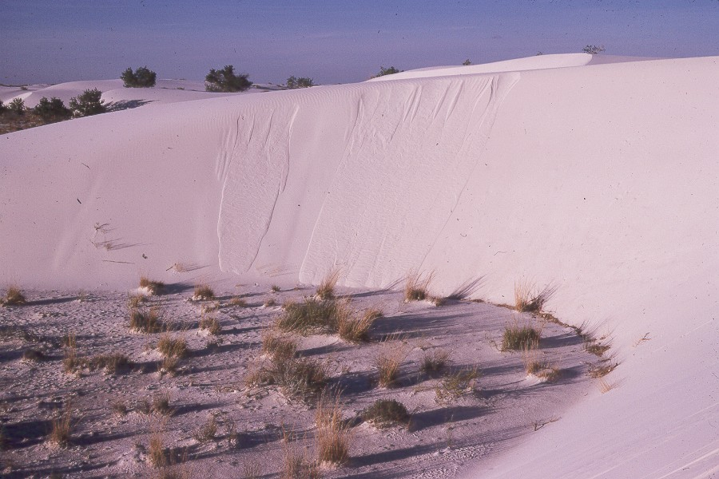

Dunes Courtesy of National Park Service

Handout #3 Lake Lucero and the Gypsum Sand and Crystals

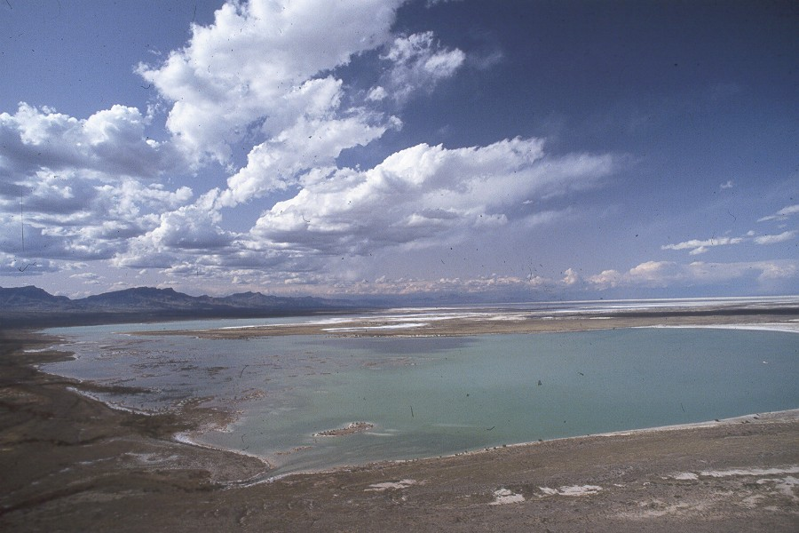

Lake Lucero Courtesy of National Park Service

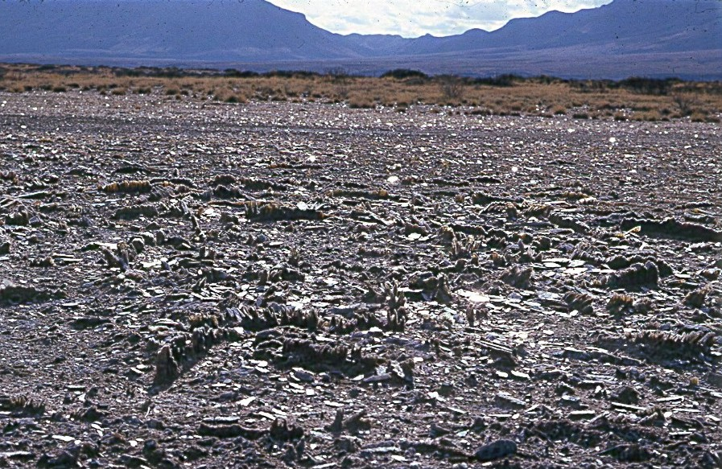

Lake Lucero Gypsum Crystals Courtesy of National Park Service

Lake Lucero, formerly Lake Otero, crystals break apart and form the gypsum sand dunes.

Handout #3 page 2

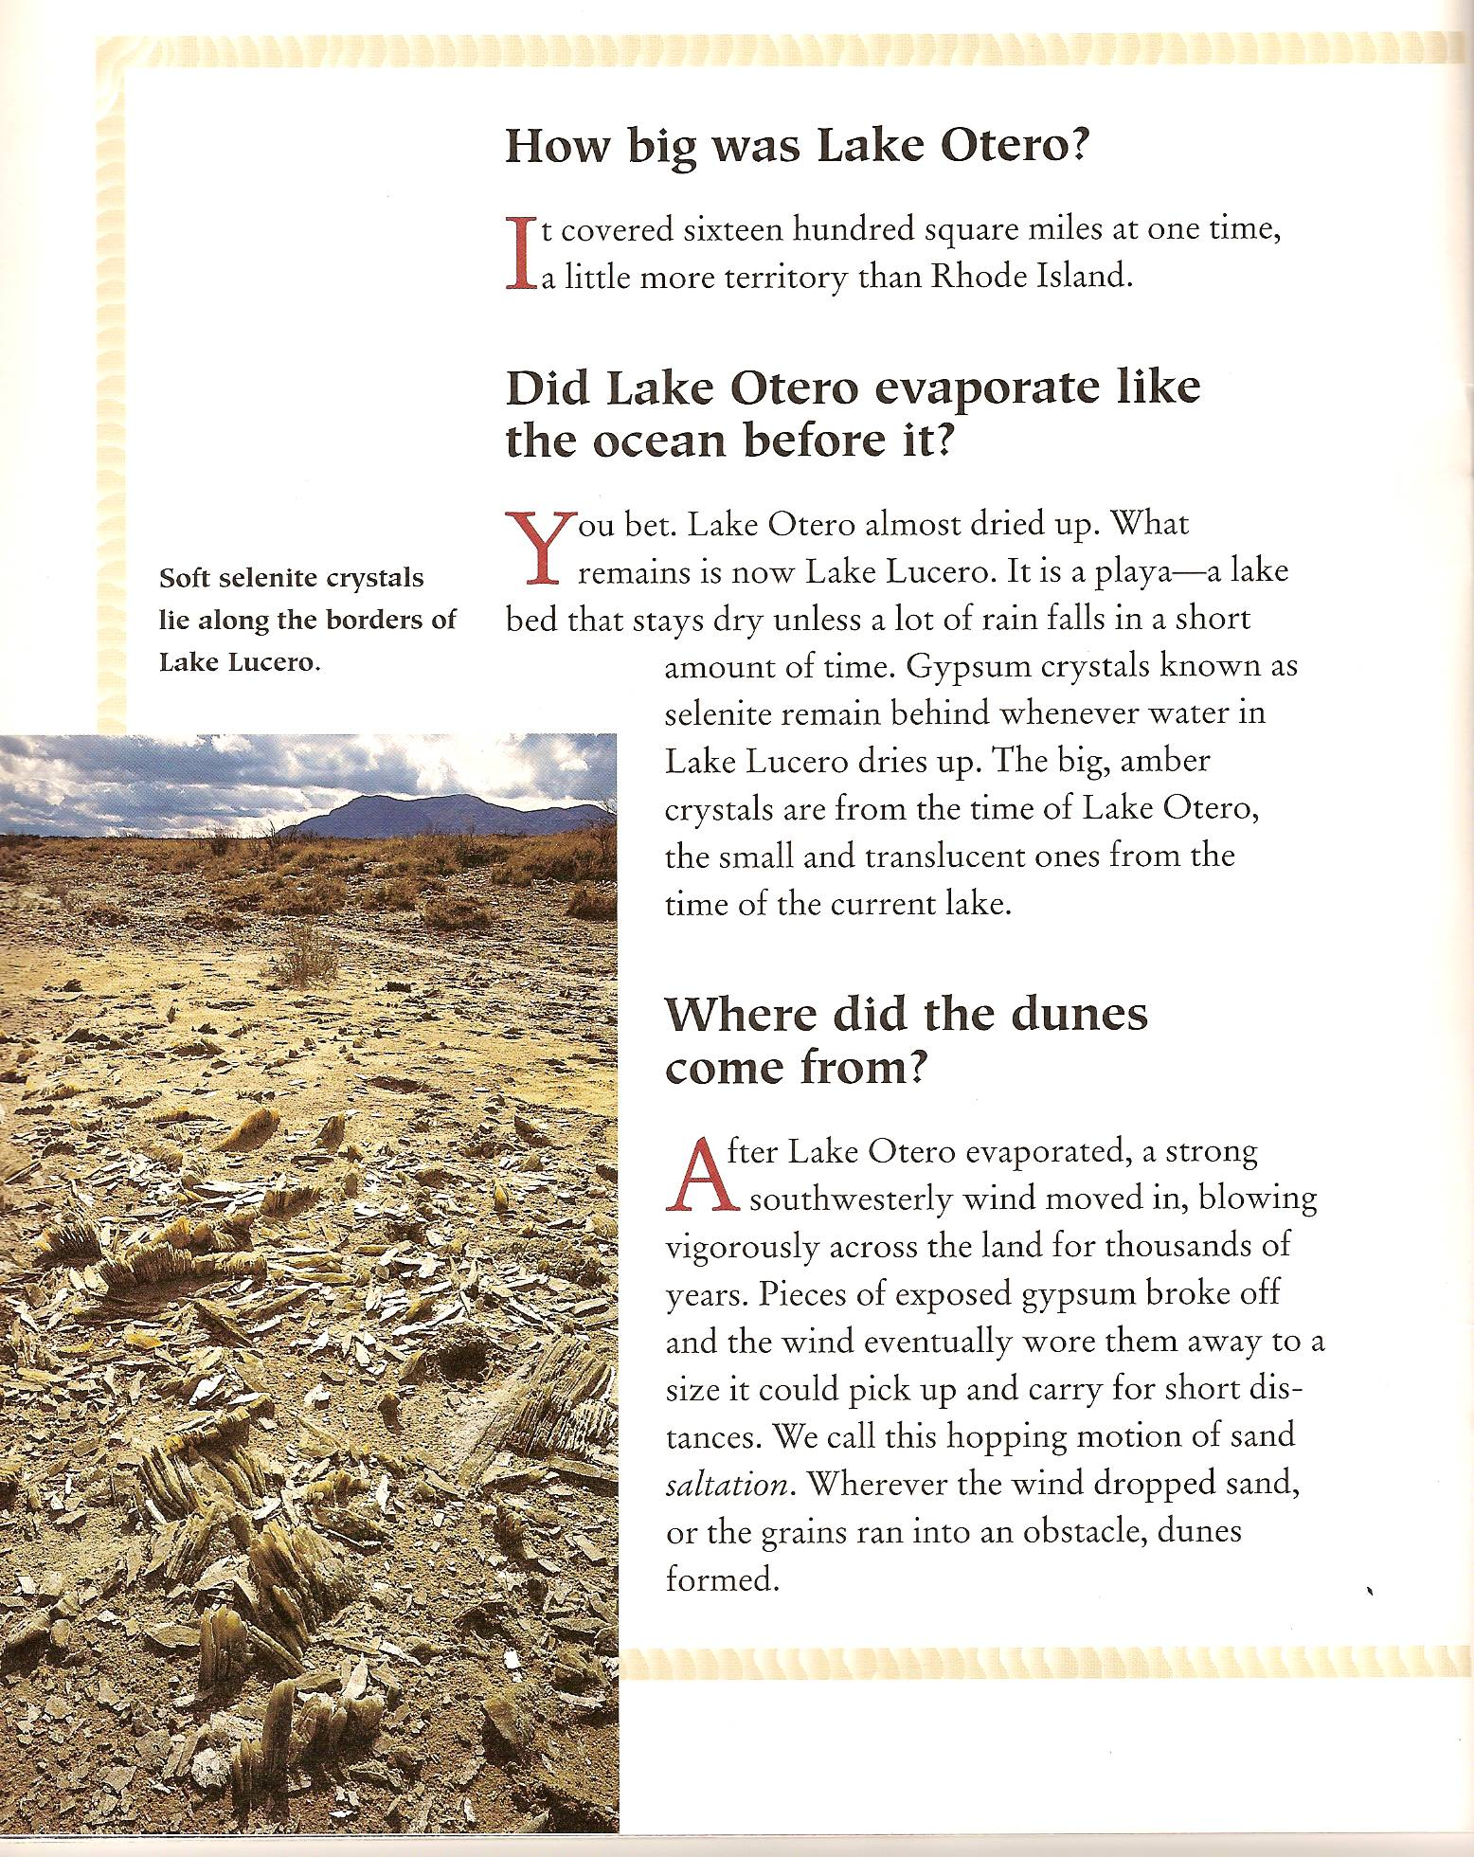

Exploring White Sands National Monument, by Mary Maruca, 1997, p. 4

Handout #4 Can Anything Live Here? page 1

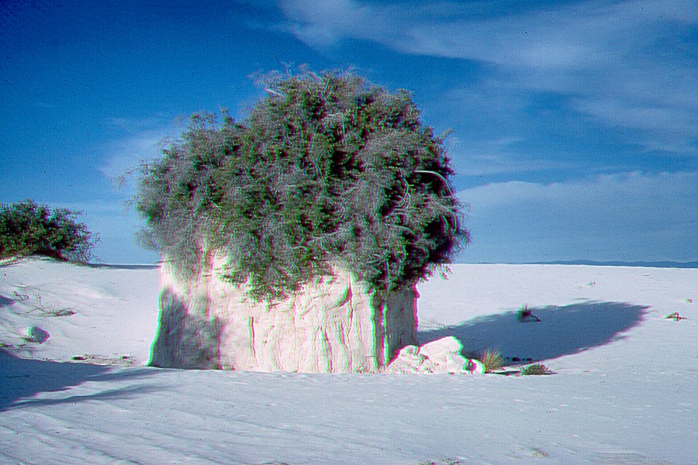

Sumac Pedestal Courtesy of National Park Service

[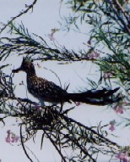](http://www.nps.gov/archive/whsa/gallery/road.jpg)

Road Runner

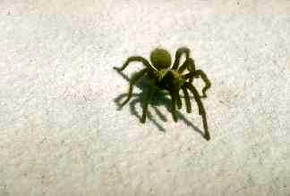

White Sands Tarantula

Handout #4 Can Anything Live Here? page 2

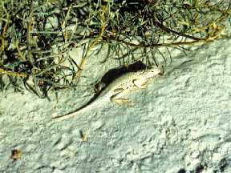

Earless Bleached Lizard

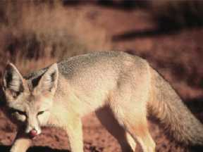

Kit Fox

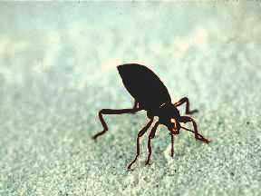

Darkling Beetle

Handout #4 Can Anything Live Here? page 3

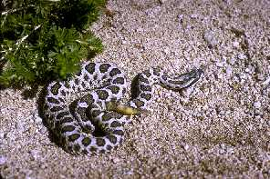

Massasauga Rattler

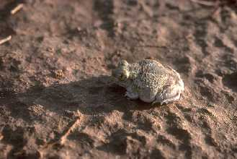

Plains Spadefoot Toad



Pallid Bat

Handout #4 page 5

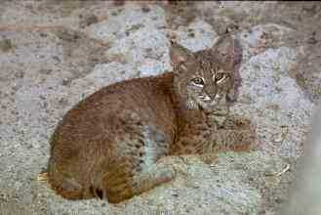

Bobcat

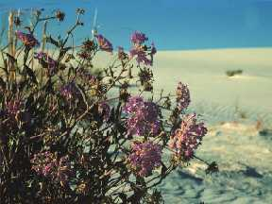

Sand Verbena

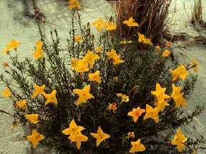

Yellow Evening Primrose

Handout #4 page 6

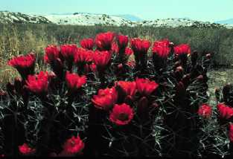

Claret Cup Hedgehog Cactus

Flowers from late April to mid-May

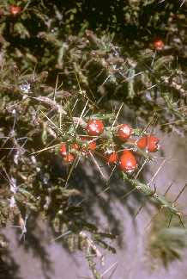

Christmas Cholla

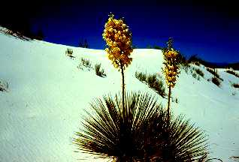

Yucca

Handout #4 page 7

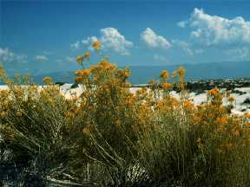

Rabbitbrush Blooms in Fall

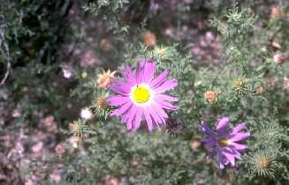

Asters Blooms in Fall

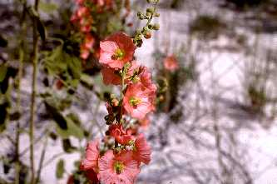

Globemallows Blooms in Fall

Handout #4 page 8

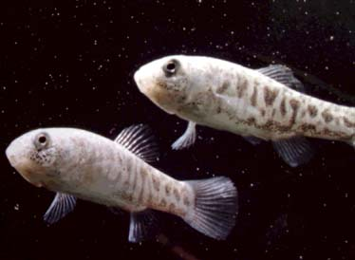

The White Sands pupfish (*Cyprinodon tularosa* Miller and Echelle 1975)

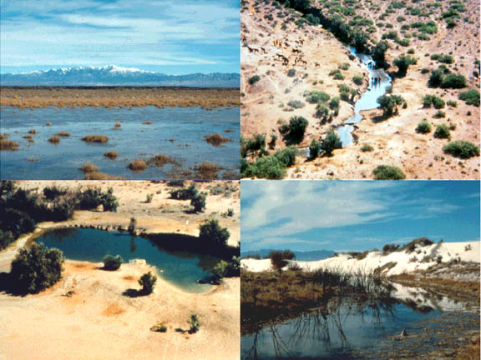

The White Sands pupfish is found four localities located in the Tularosa Basin of New Mexico: Malpais Spring, Salt Creek, Mound Spring and Lost River

Courtesy of National Park Service

Handout #5 page 1

How long did it take the white sands to expand to where they are today?

There is a clue on this page.

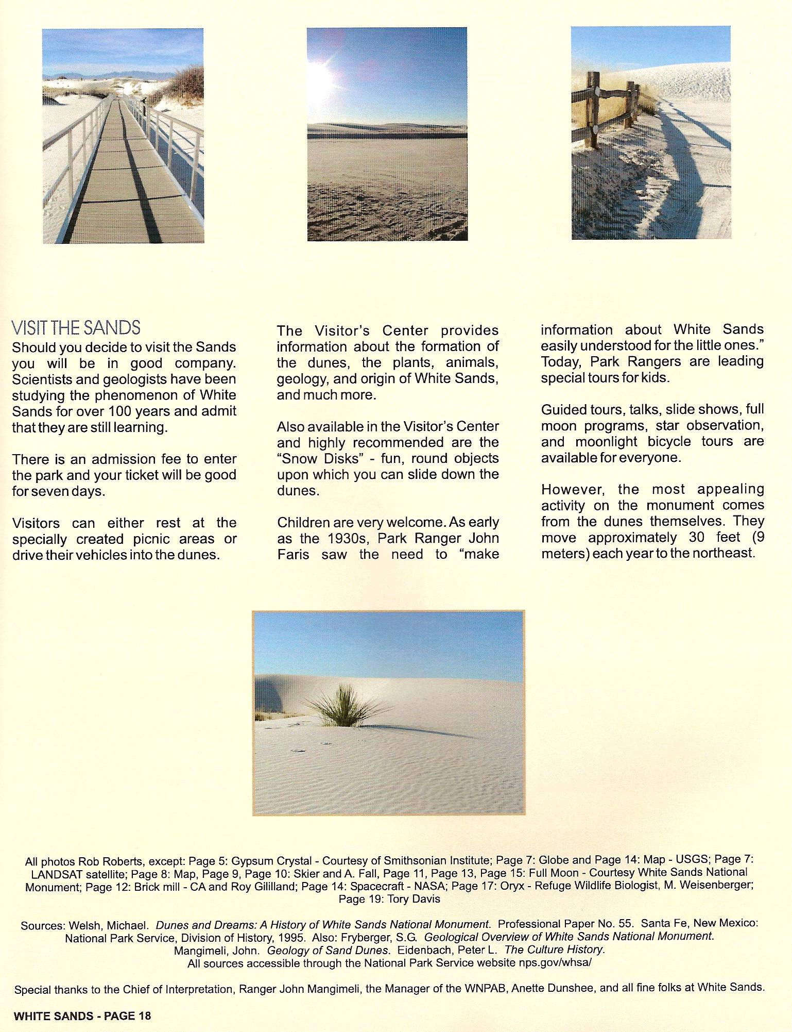

White Sands New Mexico, by Emerson Kent, 2007

Handout #5 page 2

Here is another clue.

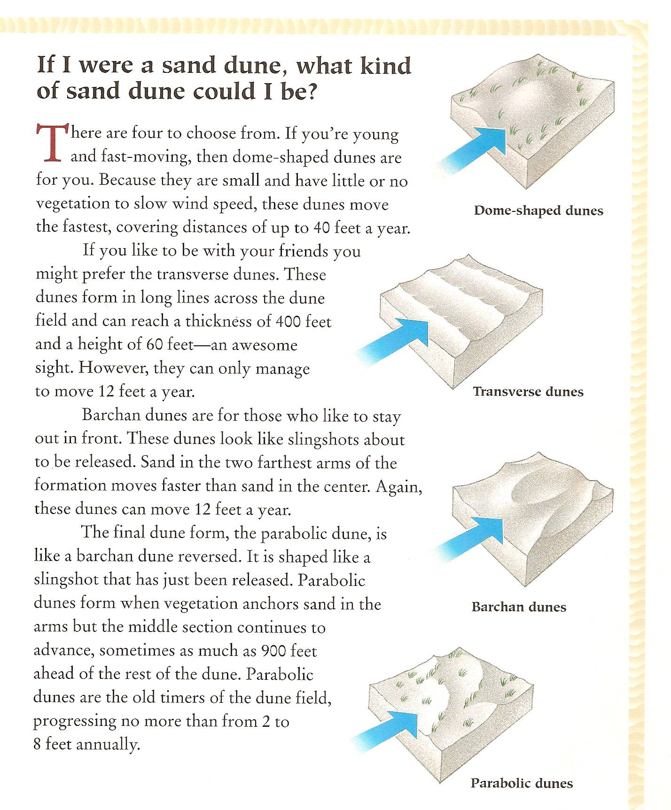

Exploring White Sands National Monument, by Mary Maruca, 1997, p. 5

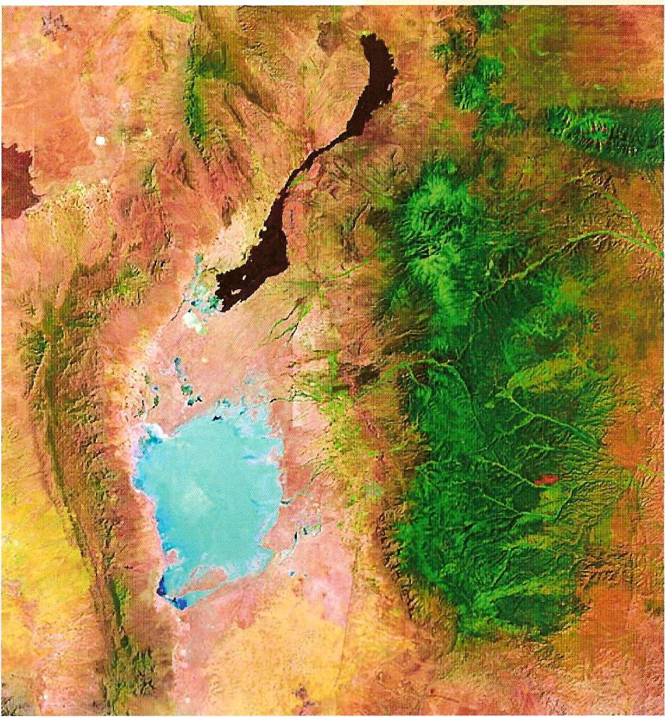

The photo is taken from the LANDSAT satellite from the Museum book entitled, White Sands, New Mexico, 2007

White Sands National Monument

Essay Scoring Rubric

Name________________________ Date_________________

How long do you think it has taken for the white gypsum sand dunes to form from the crystals found in Lake Lucero? How long do you think the pupfish have been there?

|  |  |  |  |  |
| --- | --- | --- | --- | --- |
|  | Not Evident (0) | Needs Work (15) | Acceptable (20) | Exemplary (25) |
| Mathematical Thinking | There is no evidence of mathematical thinking. | The mathematical thinking is not expressed clearly or is expressed erroneously. | The mathematical thinking is correct. | The mathematical thinking is expressed correctly and in detail. |
| Calculations | No calculations are present. | The calculations are incorrect. | The calculations are correct. | The calculations are correct and detailed. |
| Scientific Reasoning | No scientific reasoning is present. | The scientific reasoning present is incorrect. | Scientific reasoning is correct. | Scientific reasoning is correct and detailed. |
| Written Expression | The essay is not related to the topic or the essay is incoherent. | The writing is minimally coherent and/or has many grammar, punctuation, or spelling errors. | The writing is coherent, clear and understandable with few grammar, punctuation or spelling errors. | The writing is coherent, clear, expressive, and persuasive with no errors. |
| Total |  |  |  |  |